KOKKILIGADDA BALARAM
23BTRCL201
CSE-AIML
HCLTFP2316251

SECTION A: ADVANCED SQL
Question 1: Database Design and Advanced Queries (8 Marks)
a. Display employee names, department names, and manager names using joins. (2 marks
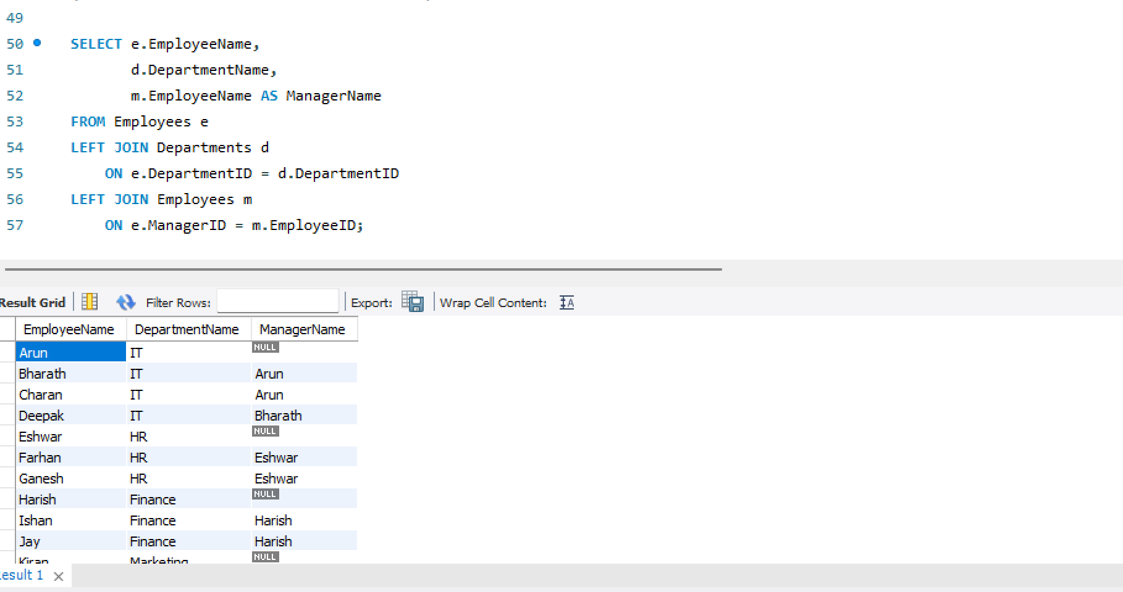
b. Find employees earning more than their department's average salary. (2 marks)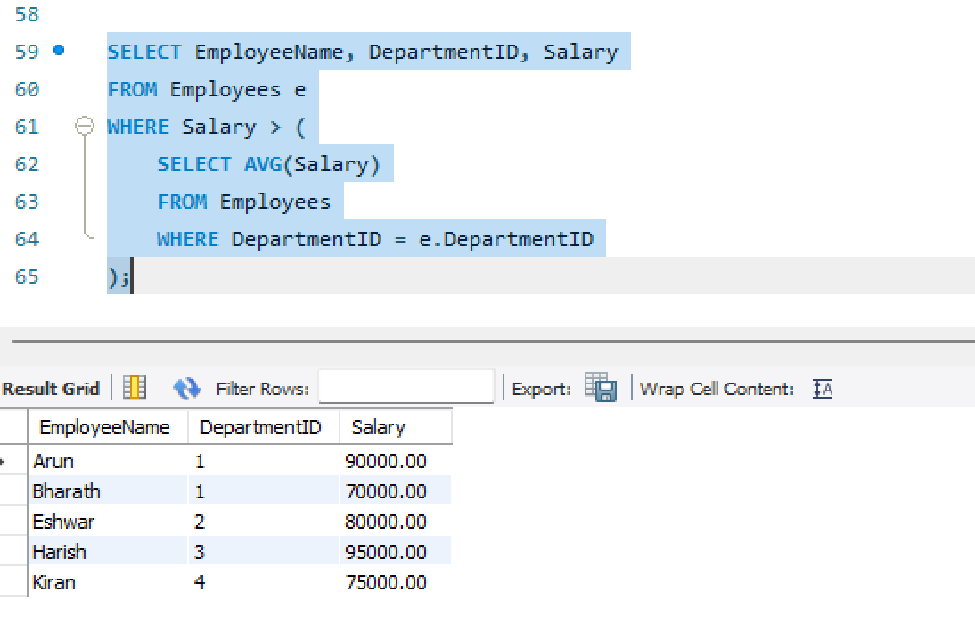

c. Find the second-highest distinct salary without using LIMIT, TOP, or FETCH FIRST. (2 marks)
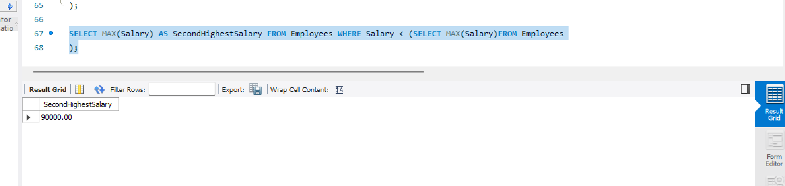
d. Rank employees by salary within each department and display the top three employees per department, retaining ties at the cutoff. (2 marks)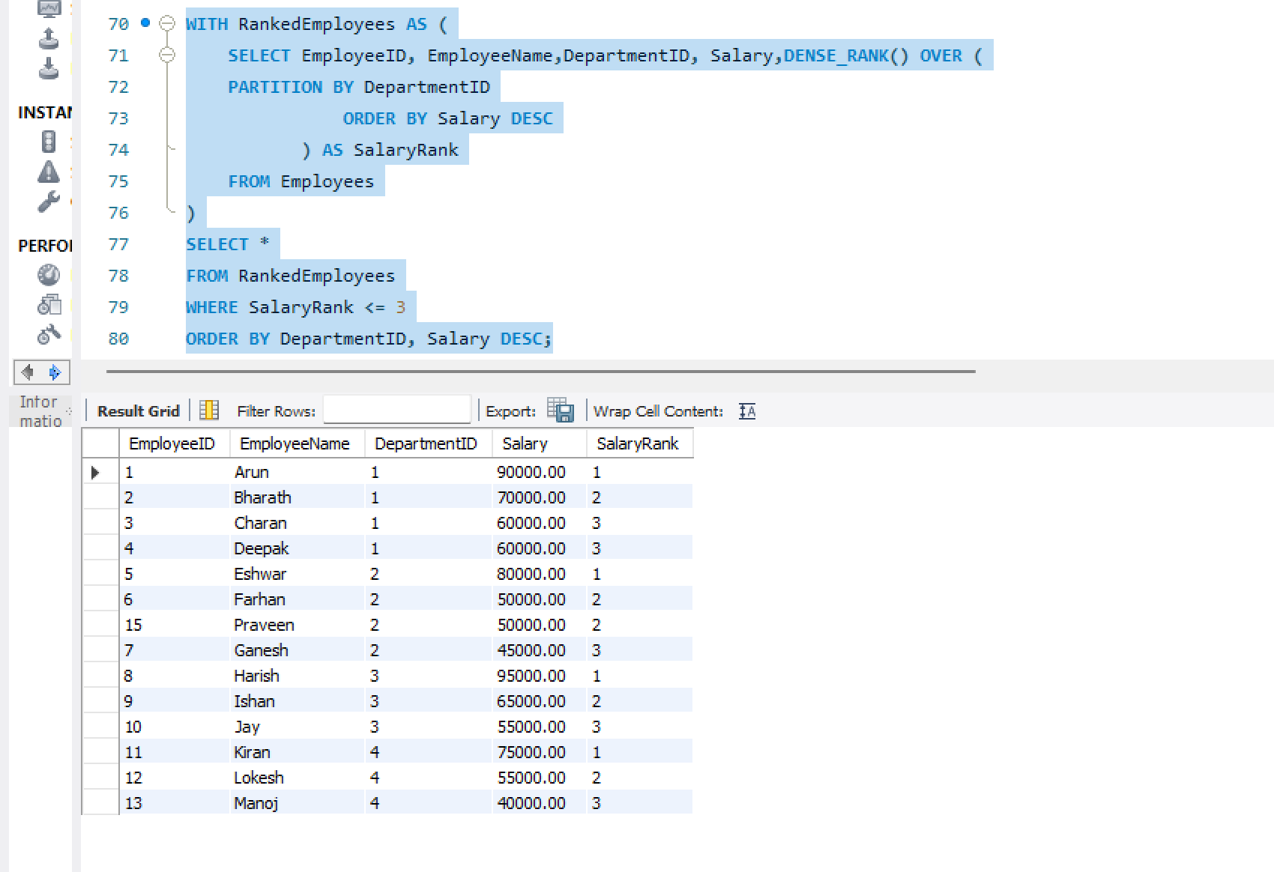

Question 2: Create a Sales table with sale id ,cutomer id ,sale date , product name ,quantity ,unitprice
a.Calculate total revenue for each product. (2 marks)
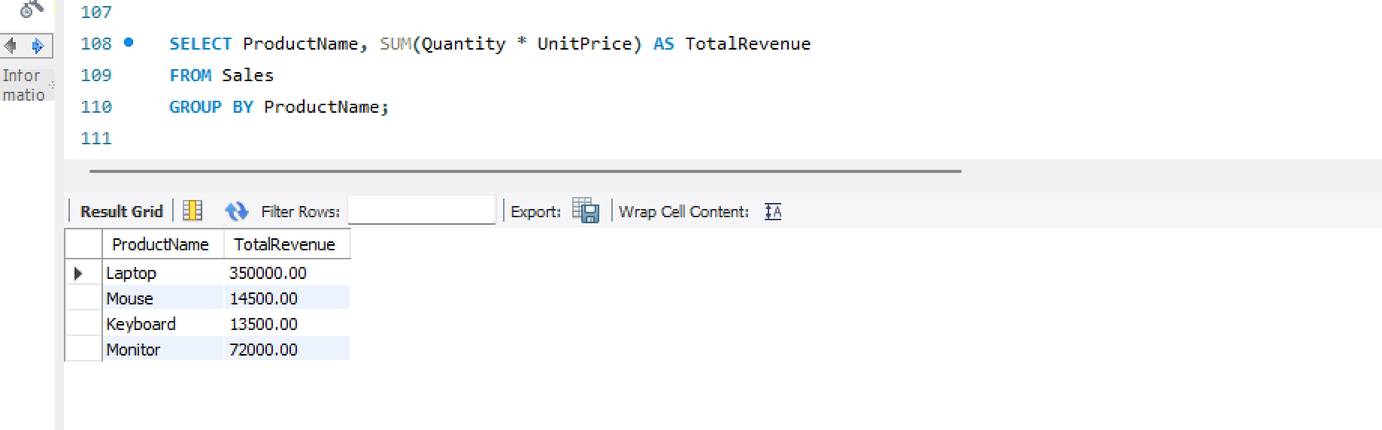

b. Calculate monthly revenue and month-over-month revenue change using a window function. (2 marks)
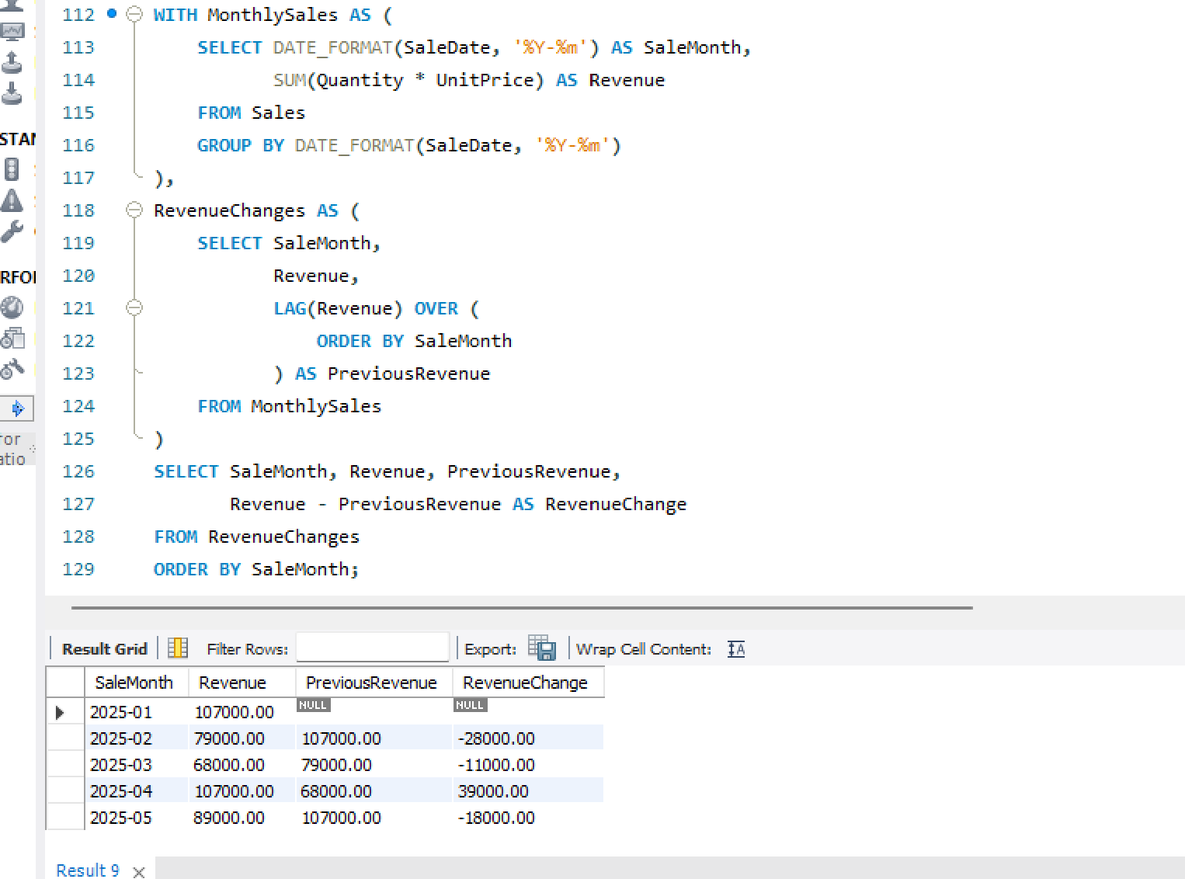

c. Rewrite the following query to improve the potential for index usage and explain why your version may perform better. (2 marks)
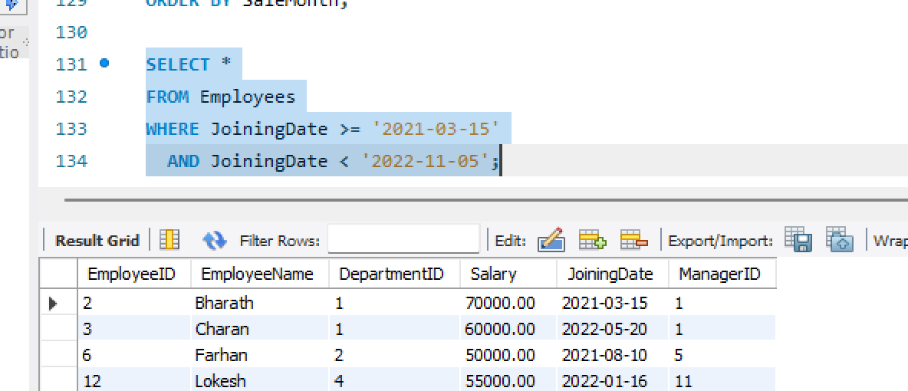

Question 3: A company maintains millions of employee and transaction records. Its reporting queries are running slowly
a.An execution plan shows how the database executes a query.
- It identifies table scans, index scans, joins and sorting operations.
- It provides estimated costs and row counts.
- It helps locate slow operations and unnecessary full table scans.
- Developers can improve performance by adding appropriate indexes or rewriting queries.

b. Recommend an appropriate index strategy for queries filtering employees by DepartmentID and Salary. Explain your reasoning. (2 marks)
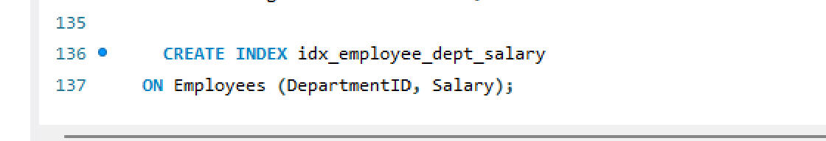
- Creating index strategy for the filtering employees by the department id and the salary I would like to sugget the simplest query to by using the “ON” where it can compare the employees by comparing the salary and the departmentID.

c. Write a query to identify duplicate customer email addresses and display only addresses occurring more than once. (2 marks)
- I would like to recommend the query which identify the duplicate customer email address and display the address occurring only once
- I’ll be using the count and having where it is used to filter the email address for
- And ill use GROUP BY to comparing and filtering the email address from the customers table and the values
example:
SELECT Email, COUNT(*) FROM Customers GROUP BY Email HAVING COUNT(*) > 1;

SECTION B: LINUX
Question 4: Log Analysis (5 Marks)
- FIRST create the file and inside the file add the data and error lines if the file is not created already
- After creating the file
- Find all lines containing ERROR. (1 mark)
- grep 'ERROR' "$LOG" using this command helps to find the error lines in the file which is /var/log/application.log
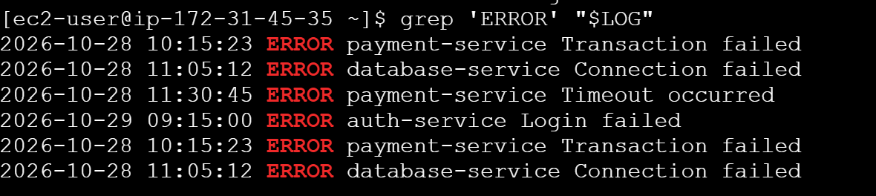
- Display the 20 most recent error entries in the file. (1 mark)
- grep 'ERROR' "$LOG" | tail -n 20 Tail is used to display the last lines of the file here I jave inserted file few error log file show it is displaying how many logs ive insterted it is showing them
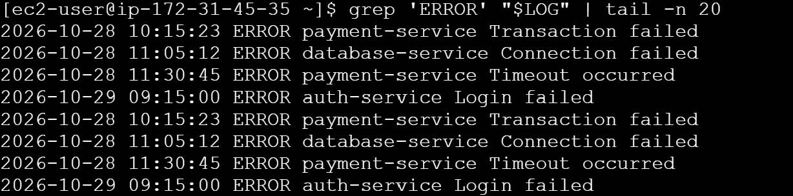
- Count the total number of error entries. (1 mark)
- grep -c 'ERROR' "$LOG"
d. Extract error entries for a specified date into a separate file. (1 mark)
- grep '^2026-10-28 .*ERROR' "$LOG" > ~/errors_2026-10-28.log cat ~/errors_2026-10-28.log we are saving the file bbythe date of 2026-10-28 and the cat is used to display the saved error log files ive saved it twice it is showing 8
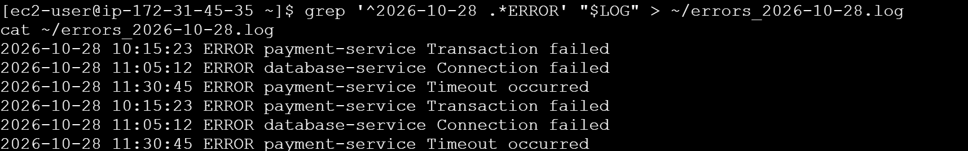
e.Explain how you would calculate the number of errors occurring in each hour. (1 mark)
- awk filters error entries, extracts the hour from the timestamp, and counts errors per hour. sort displays the results in hour order.
Question 5: Permissions and System Troubleshooting
a. Create a group named finance and a report file, assuming you have the required privileges. (1 mark)
- sudo groupadd finance sudo touch report.txt using these command to creating the the report finance in the group finance and sudo is used to execute the command
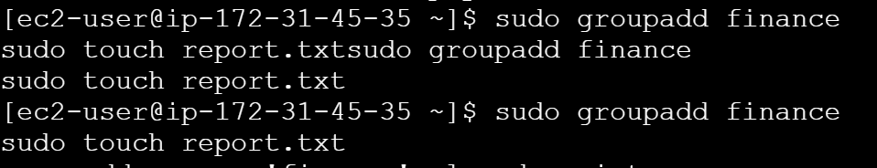
b. Set permissions so the owner can read and write, the finance group can read, and other users have no access. (1 mark)

c.Identify the processes consuming the most CPU. (1 mark)
- using top command
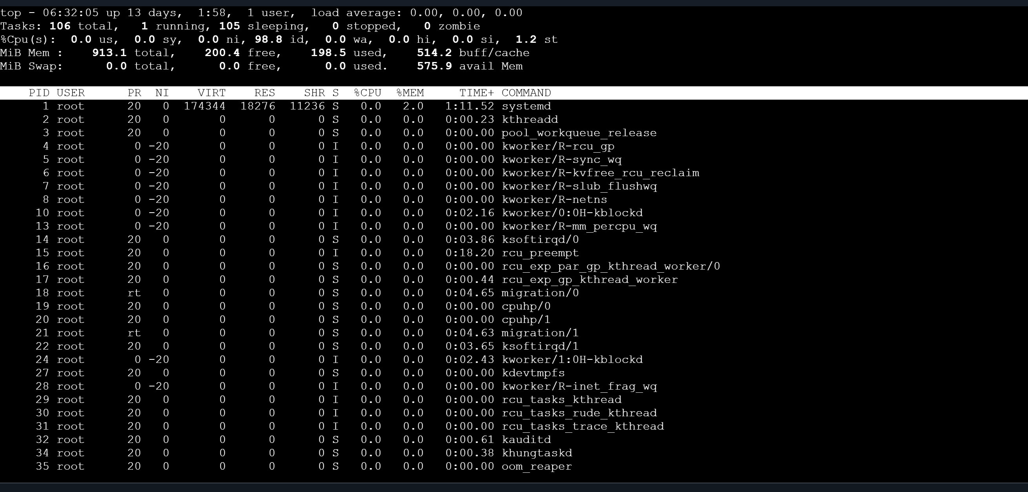
- Display memory usage and filesystem disk utilization. (1 mark)
- Df -h is used to filesystem utiliztion
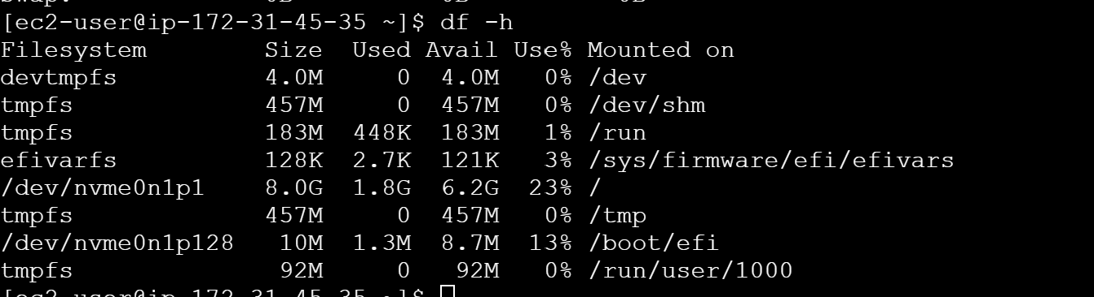
- Free -h used to memoeryusage
SECTION C: PYSPARK DATA ENGINEERING
Create a PySpark DataFrame
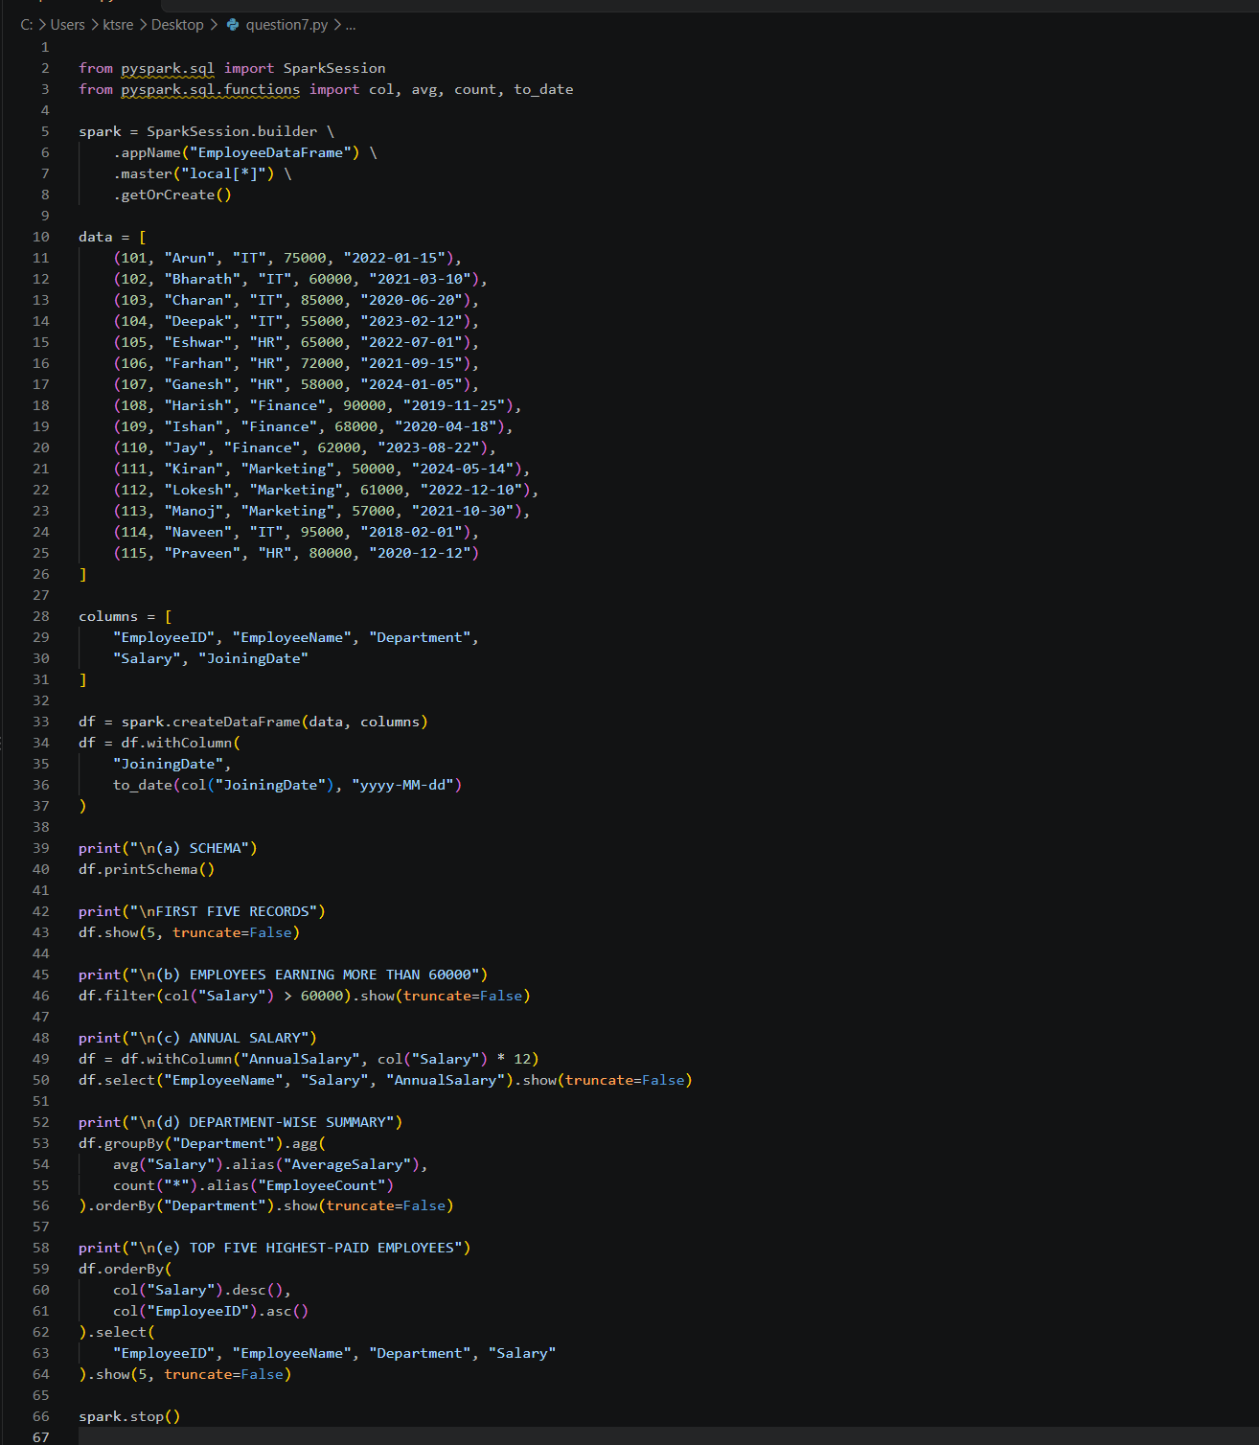

Question 7 PySpark DataFrame Operations:
- Display the schema and first five records. (1 mark)
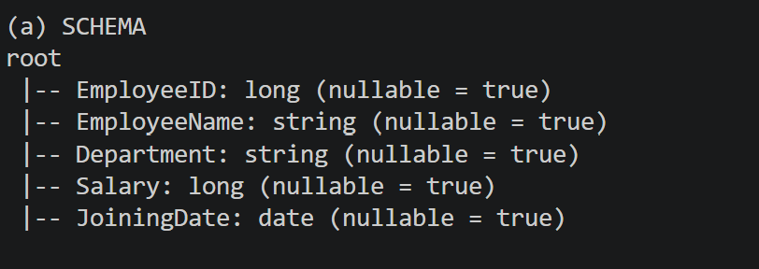
- Filter employees whose monthly salary is greater than ₹60,000. (1 mark)
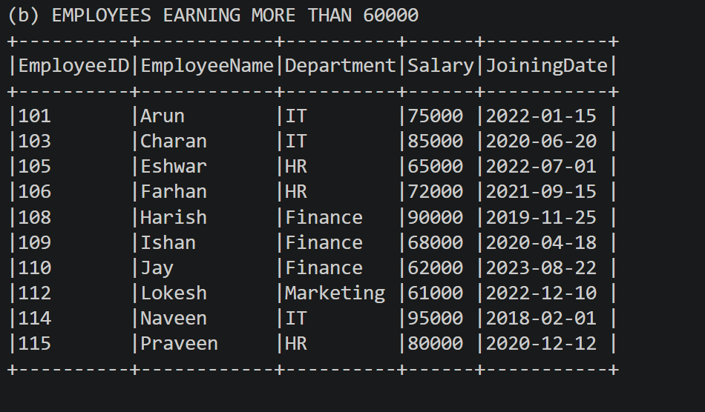
- Add an AnnualSalary column calculated from the monthly salary. (1 mark)
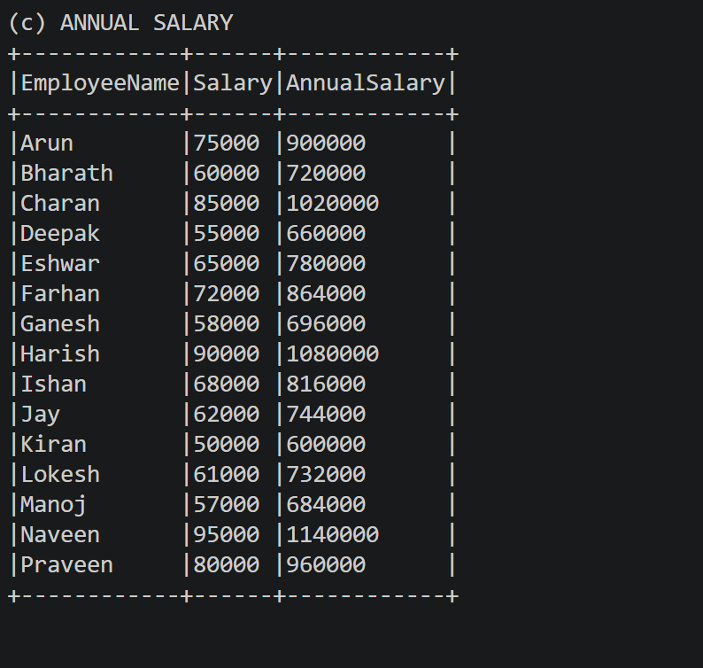
- Group employees by department and calculate the average salary and employee count. (2 marks)
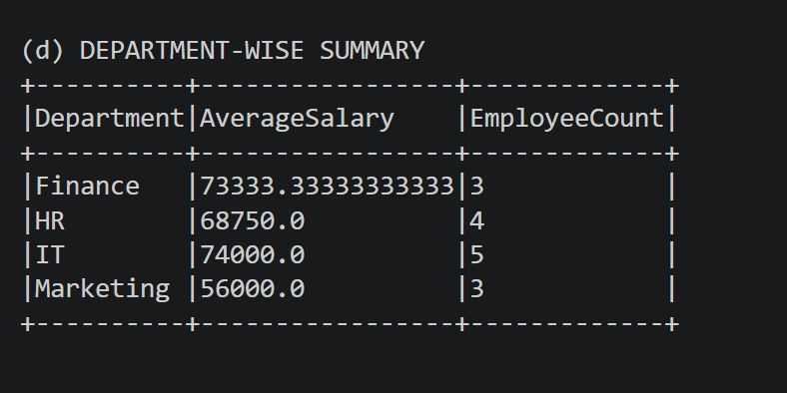

Question 8: Data Cleaning and Aggregation
- Read the CSV file using an appropriate schema and header configuration. (1 mark)
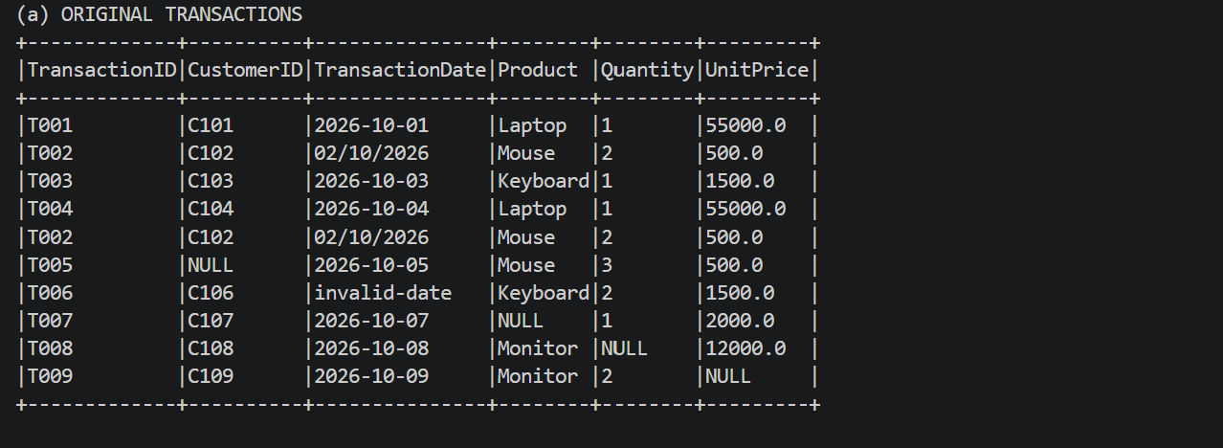
- Identify and remove duplicate transactions using a suitable business key. (1 mark)
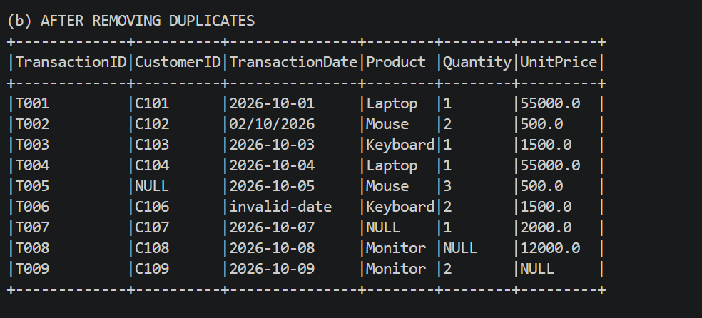

c. Handle missing values in required fields and explain your chosen approach. (2 marks)
- the dropna() function removes records containing missing values in the specified required columns.
- This approach is chosen because missing transaction details can lead to incorrect revenue calculations and unreliable analysis.
d.Convert TransactionDate into a date type and handle invalid dates. (1 mark)
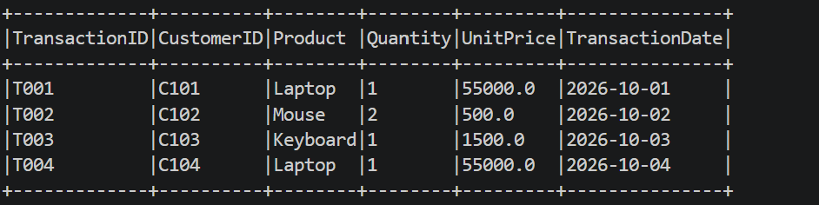
e. Calculate revenue using Quantity × UnitPrice. (1 mark)
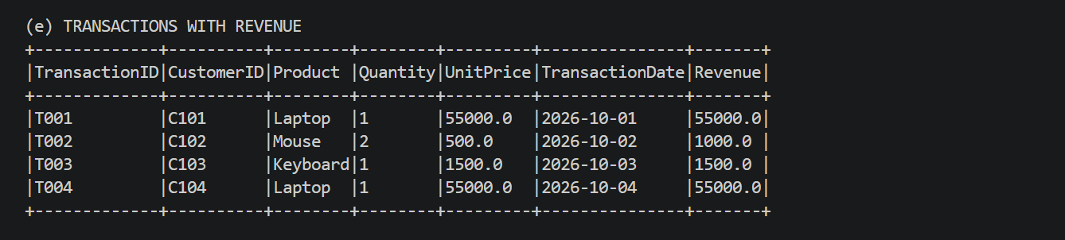
f.Calculate total revenue by product and display the results in descending order. (1 mark)
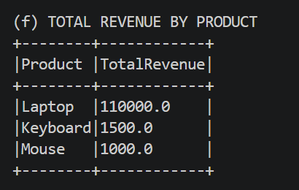
Code:
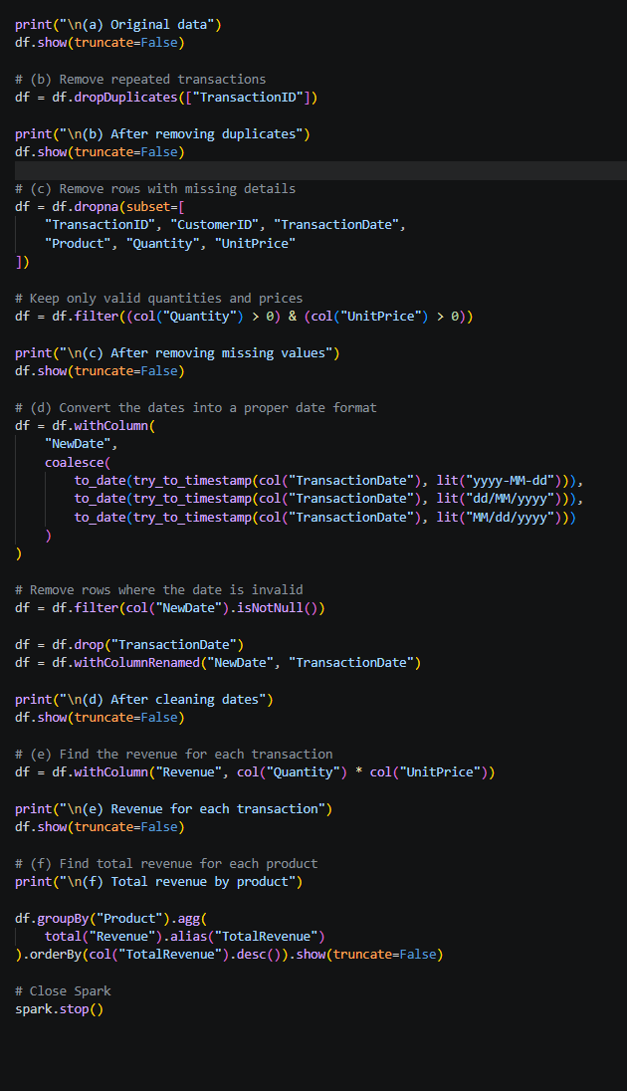
Question 9: PySpark Joins and Performance
- Load both datasets into DataFrames. (1 mark)
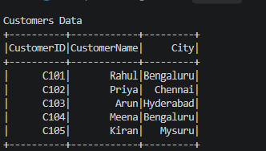

b. Join the datasets to display orders with customer details. (2 marks)
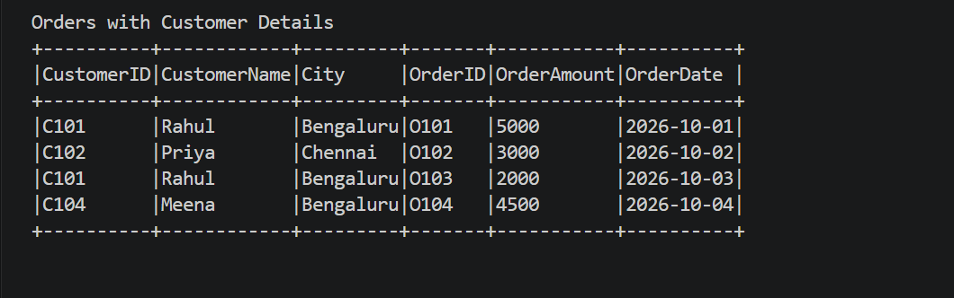
c.Identify customers who have never placed an order. (1 mark) 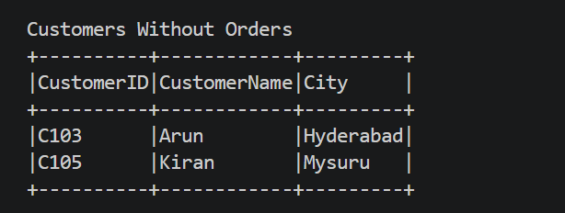
d. Calculate the total order value by city. (1 mark)
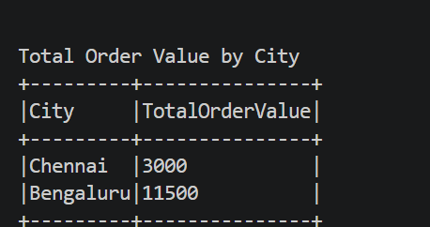
- Explain when a broadcast join is useful and what conditions make it appropriate. (1 mark)
- A broadcast join is useful when one DataFrame is small enough to fit in the memory of each worker. Spark sends the smaller DataFrame to all workers, reducing data shuffling and improving performance.

- f. Explain the difference between transformations and actions, giving one example of each. (1 mark)

- A broadcast join is useful when one DataFrame is small enough to fit in the memory of each worker. Spark sends the smaller DataFrame to all workers, reducing data shuffling and improving performance.

SECTION D: AWS CLOUD SERVICES:
Question 10: S3 and IAM Security:
a. Create an S3 bucket with Block Public Access enabled and upload a sample file. (1 mark)
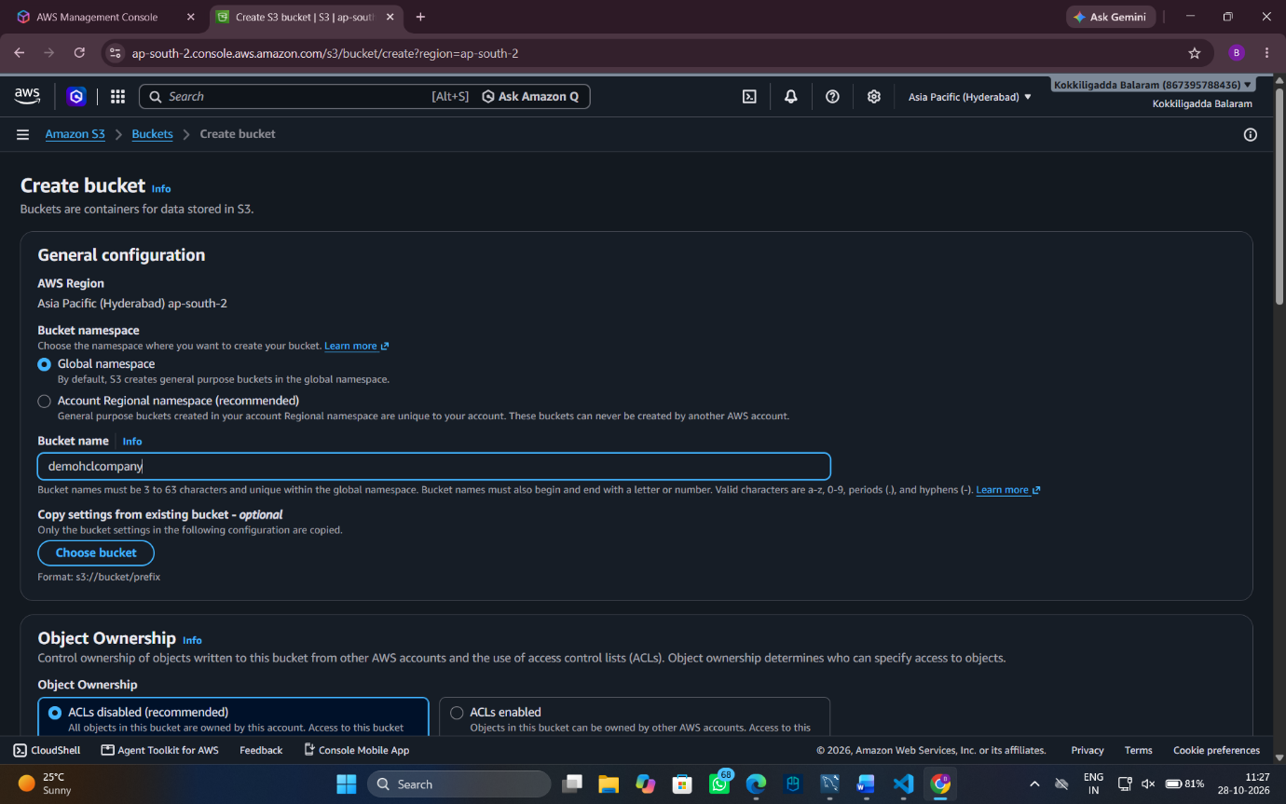

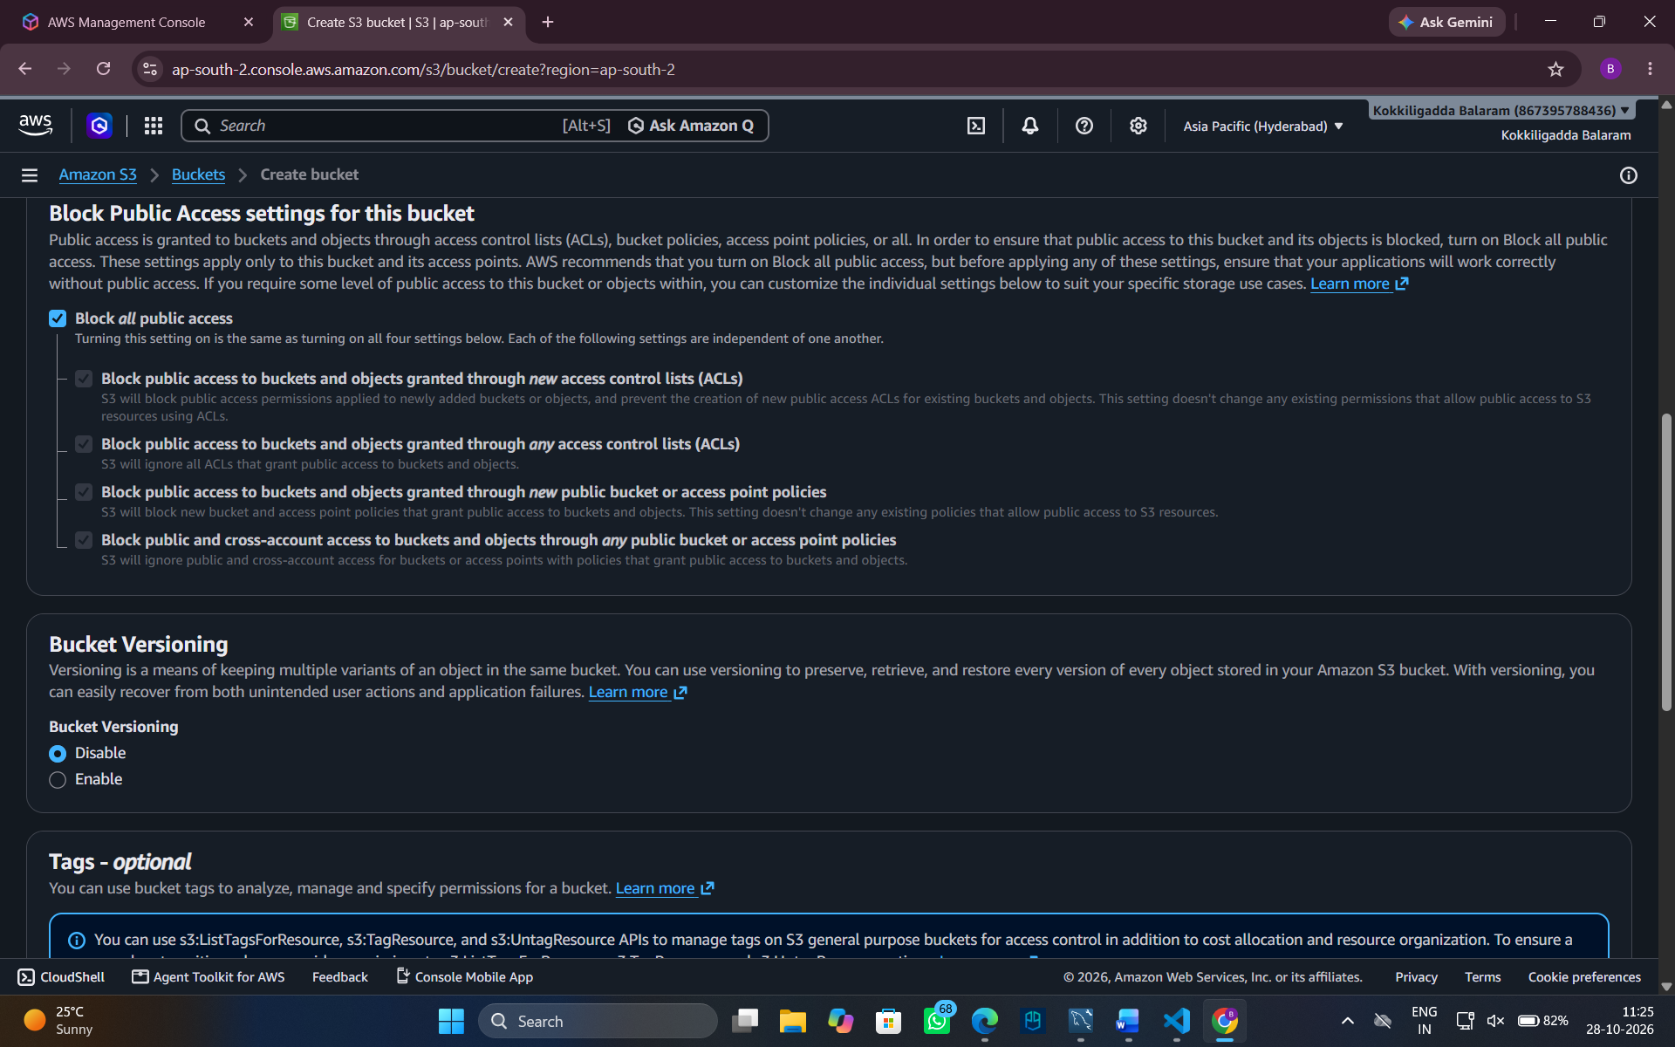

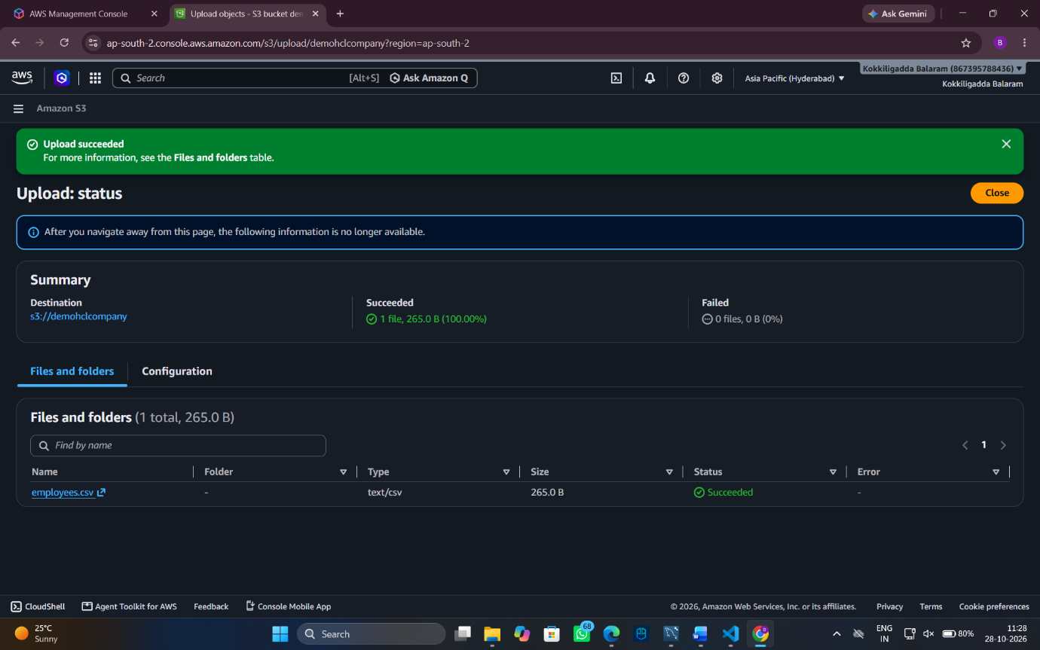

c.Explain how you would verify that an unauthorized user cannot read the file.
- Sign in using an IAM test user that does not have permission to access the bucket.
- Attempt to open or download employee_report.txt.
- Verify that AWS returns Access Denied.
d.Explain how encryption at rest protects the stored data.
- Encryption at rest protects stored S3 data by converting it into an unreadable encrypted form.
- Amazon S3 automatically encrypts all stored data at rest using SSE-S3 (AES-256) by default at no extra cost.
Question 11: EC2 Troubleshooting and CloudWatch (5 Marks):
- Check the EC2 instance state and status checks. (1 mark):
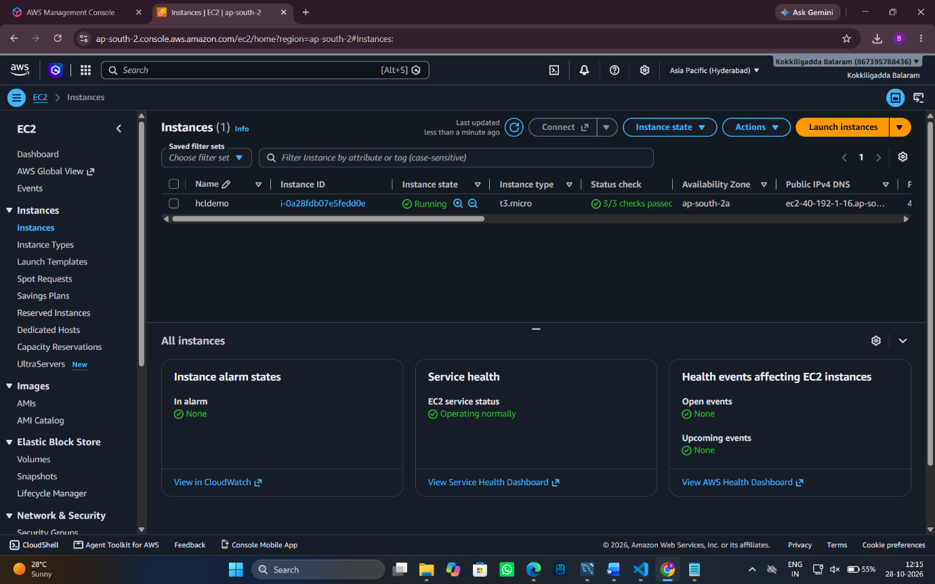

- Explain how security groups and route tables can affect application connectivity. (1 mark):
- Security groups: Allow or block traffic through specified ports. HTTP uses port 80 and HTTPS uses port 443.
- • Route tables: Direct network traffic. Incorrect routes or a missing internet gateway route can prevent users from reaching the application.
- Explain how to configure a CloudWatch alarm when CPU utilization exceeds 85% for a defined evaluation period. (2 marks)
- Open Amazon CloudWatch and select Alarms and Create alarm.
- Select the EC2 instance's CPUUtilization metric.
- Set the CPU utilization greater than 85% and choose an evaluation period of 5 minutes.
- Name the alarm and create it.
- The alaram will get on when it come to the threshold 85% .
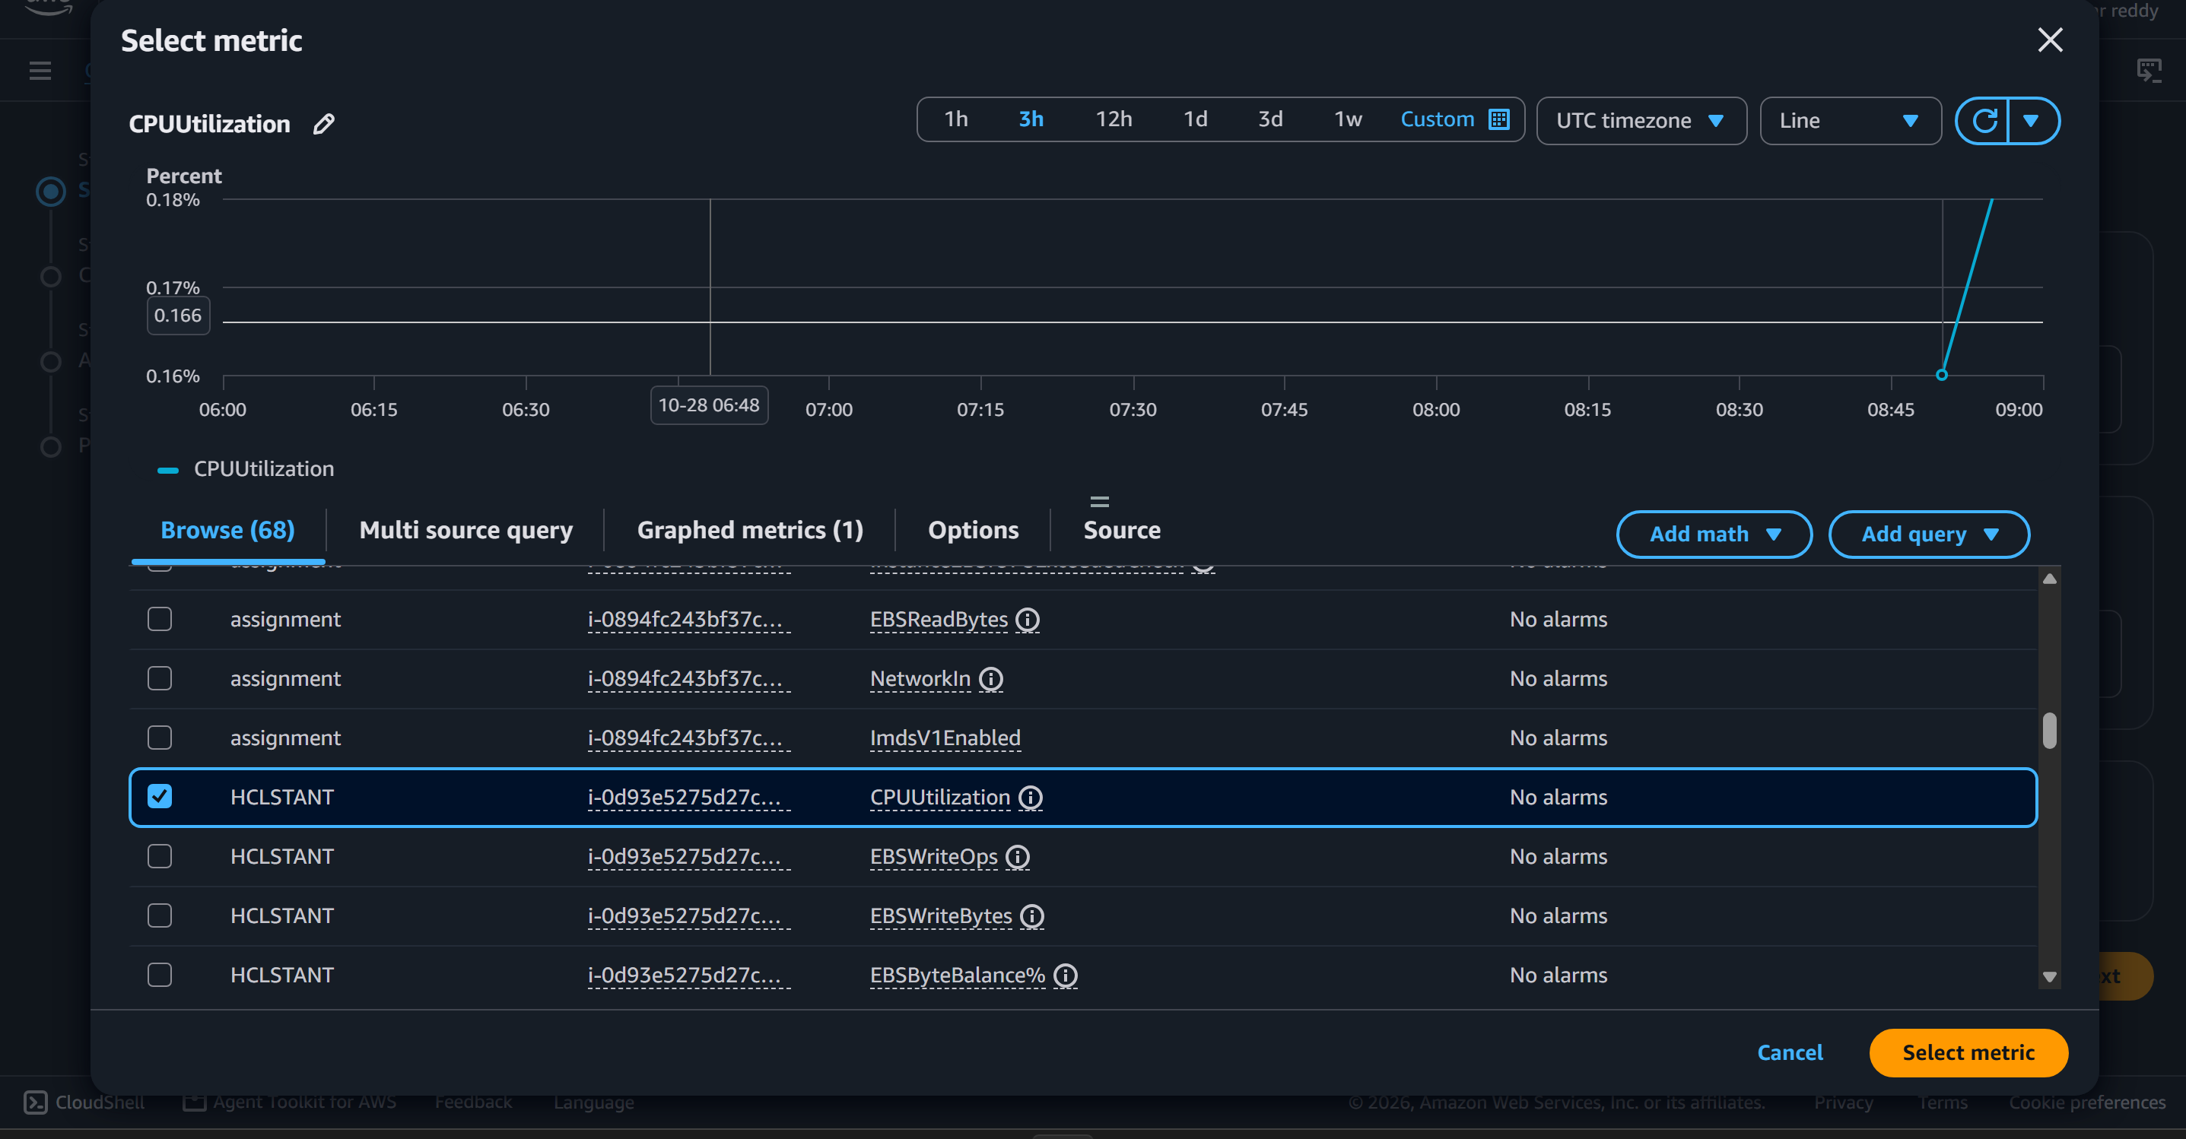
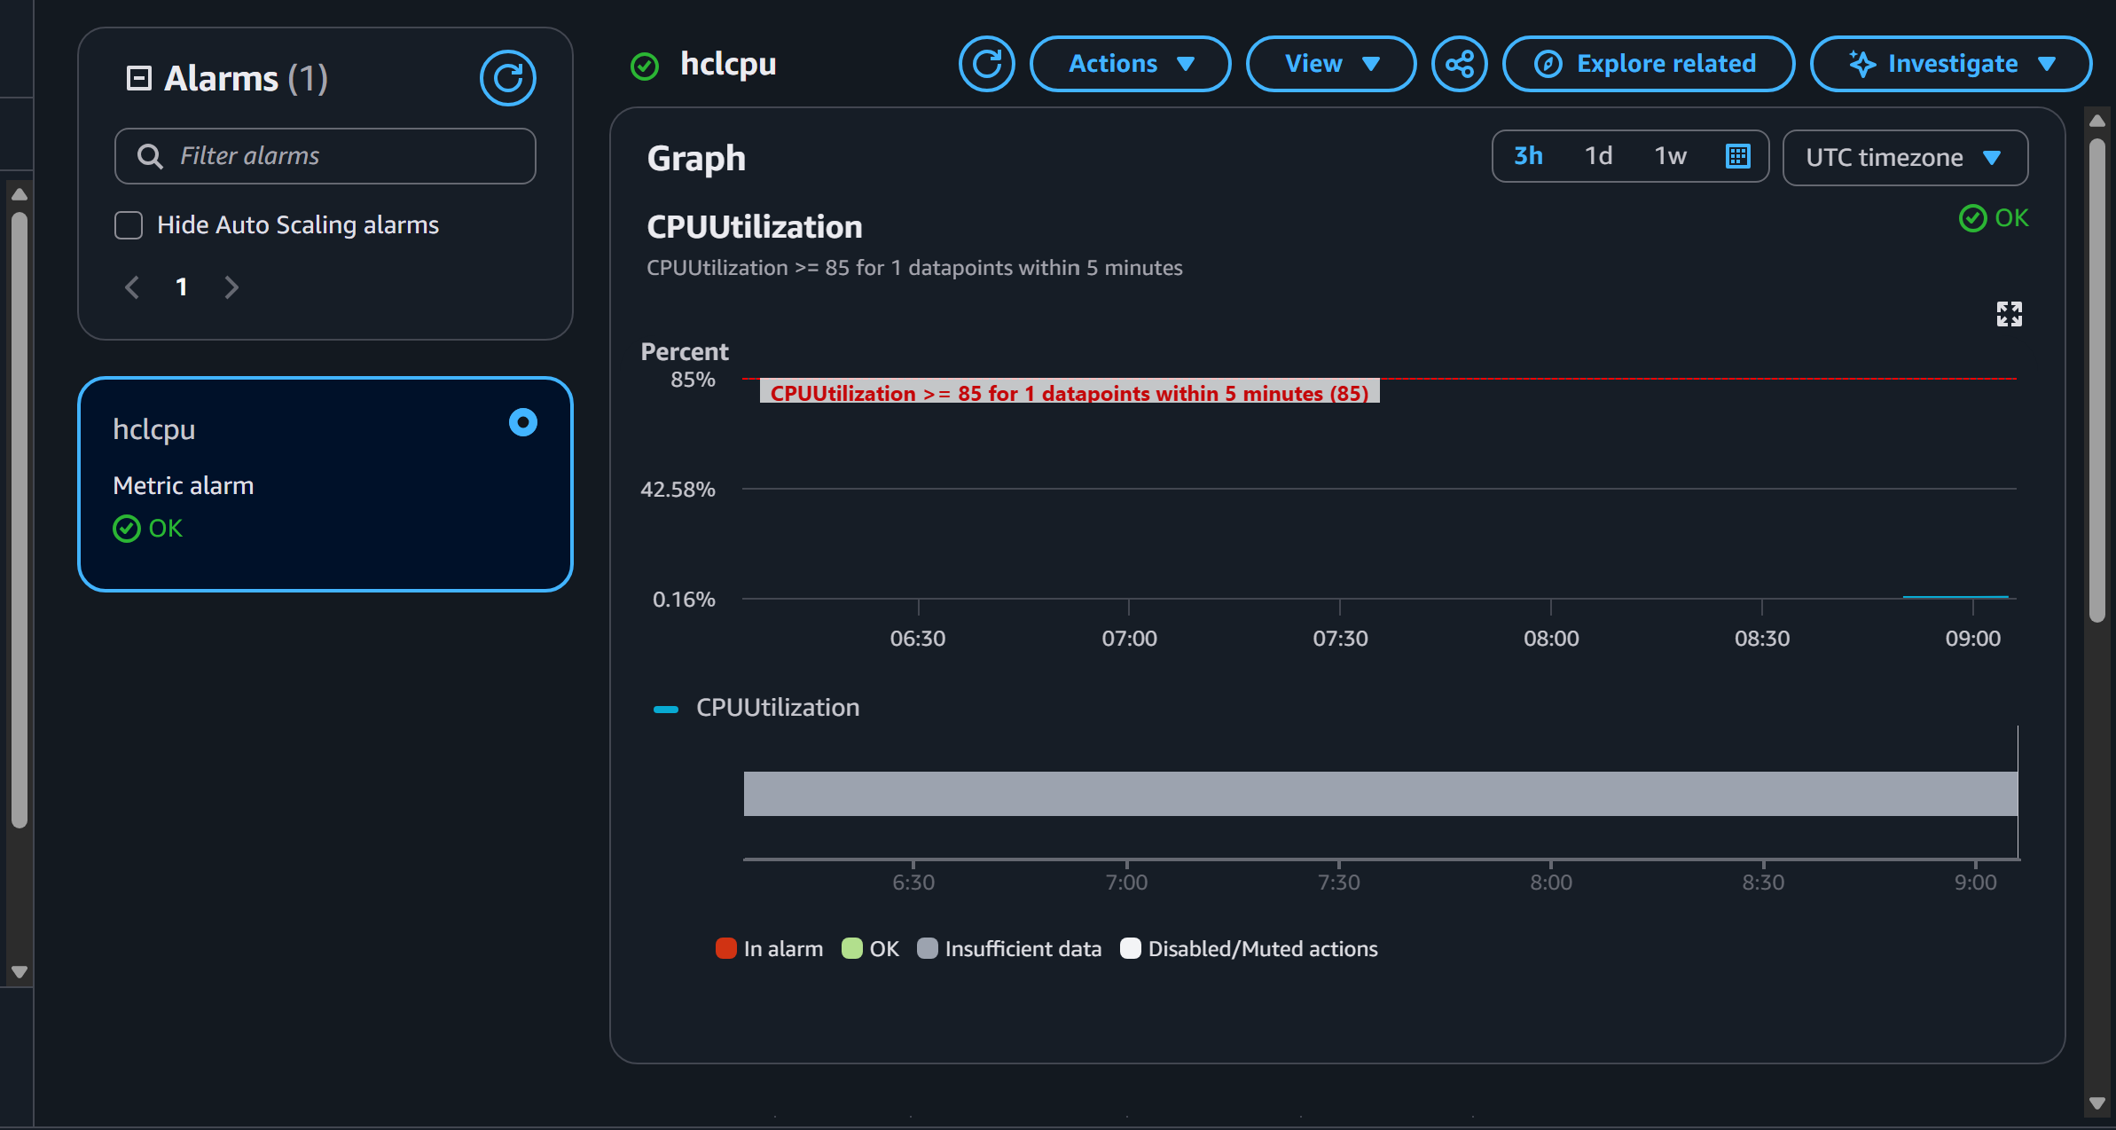

d. Identify one method for investigating the root cause of high CPU utilization. (1 mark)
- We’ll use the command “top” to investigate the root cause of high cpu utilization it should be done by connecting the ec2 instance to the server.

Question 12: Event-Driven Processing (5 Marks):
(a) Identify a suitable service for executing the processing code. (1 mark)
- AWS Lambda is suitable for running processing code automatically without managing servers.
(b) Explain how an S3 upload can trigger processing. (1 mark)
- Configure an S3 Event Notification to trigger a Lambda function whenever a new file is uploaded to the input bucket.
(c) Explain the IAM permissions needed to read the input file and write the results. (1 mark)
- Give the Lambda execution role permission to read input files using
- s3:GetObject and write results using
- s3:PutObject on the required S3 bucket paths only.
(d) Explain how errors and processing logs can be captured. (1 mark)
- Use Amazon CloudWatch Logs to store Lambda execution logs and error messages. CloudWatch can also monitor failures and help troubleshoot problems.
(e) Explain how to prevent duplicate processing or recursive triggering. (1 mark)
- Use a unique file key or event ID to detect duplicate processing.
- Store output files in a separate S3 bucket or a different folder from the input files to prevent the Lambda function from triggering itself repeatedly.

SECTION E: AWS STEP FUNCTIONS:
Question 13: State Machine Design (7 Marks):
- Identify suitable states for validation, processing, storage, and notification.
The workflow uses AWS Step Functions to coordinate Lambda functions.
Start
Validate File — Task
Is Valid? — Choice
Valid
Transform Data
Calculate Sales
Store in S3
Send Notification
Success
Invalid
Fail State

- Explain how a Choice state can route invalid files to a failure path and valid files to processing.
A Choice state evaluates a condition in the input data and selects the appropriate transition. For example, if $.isValid is true, the workflow continues to TransformData; otherwise, it moves to FailInvalidFile.

- Explain how Retry and Catch can handle transient failures and permanent errors.
Retry: Automatically reruns a task after a transient error, using a configured delay and maximum number of attempts.
Catch: Handles an error that remains after retries by transferring execution to an error-handling state or failure path.

- Explain how the state machine can invoke Lambda functions or other supported AWS services.
A Task state can invoke a Lambda function using its ARN. Step Functions also supports service integrations with services such as Amazon S3, Amazon SNS and AWS Glue.

- Explain how execution history helps troubleshoot a failed workflow.
Execution history records state transitions, inputs, outputs, errors and timestamps. It identify the failed state, investigate the error and determine where processing stopped.

Question 14: Step Functions Implementation

- Explain how data from one task is passed to the next task.
Step Functions passes the output of one state to the next state as input by default. InputPath, ResultPath and OutputPath can filter or combine input and output. Lambda functions should return JSON-serializable results.
- Explain how you would test successful and failed executions.
Start an execution with valid input and verify all three tasks succeed.
Test invalid input and verify validation fails.
Simulate transient transformation errors to test retries.
Simulate a loading error and verify the error-handling state is reached.
Inspect the execution graph and history in the AWS Console.

SECTION F: MICROSOFT AZURE

Question 15: Azure Data Lake Storage and Security
- Configure or describe a storage account with hierarchical namespace enabled for Azure Data Lake Storage Gen2.
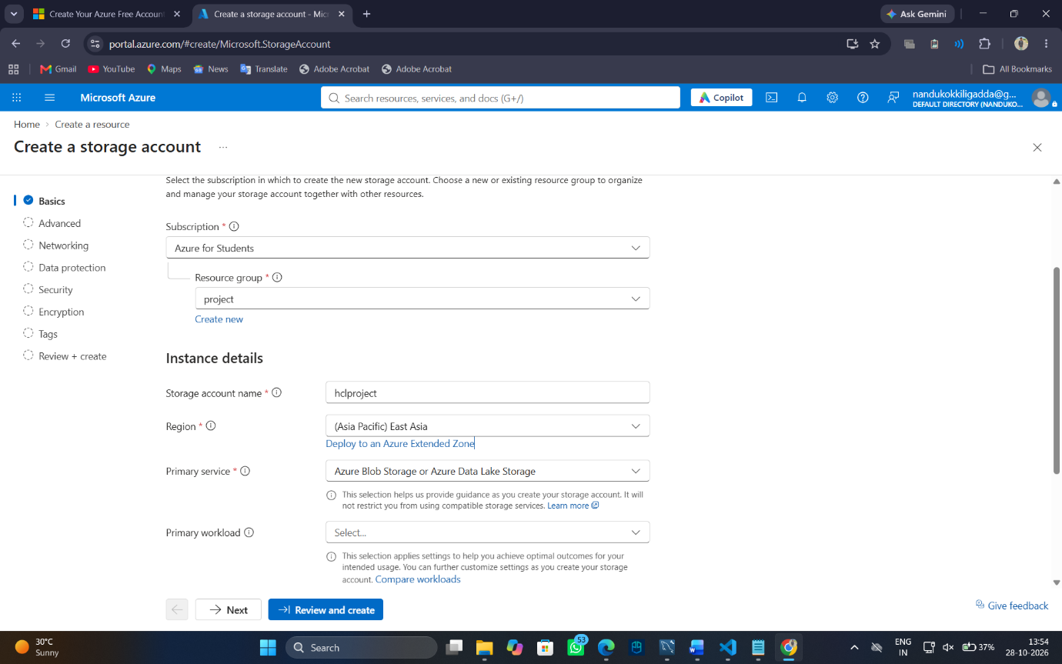
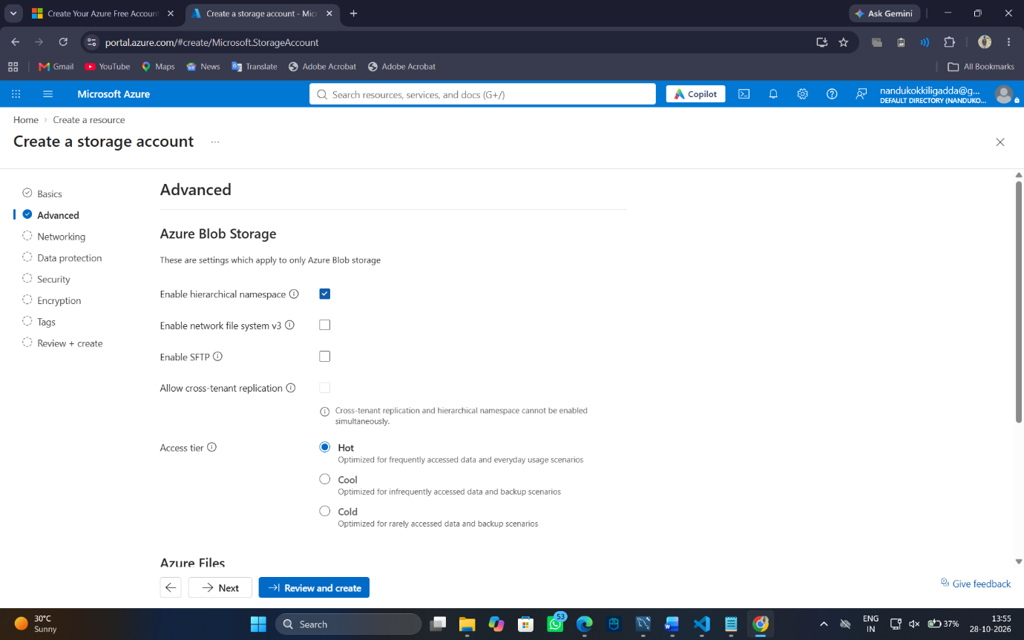
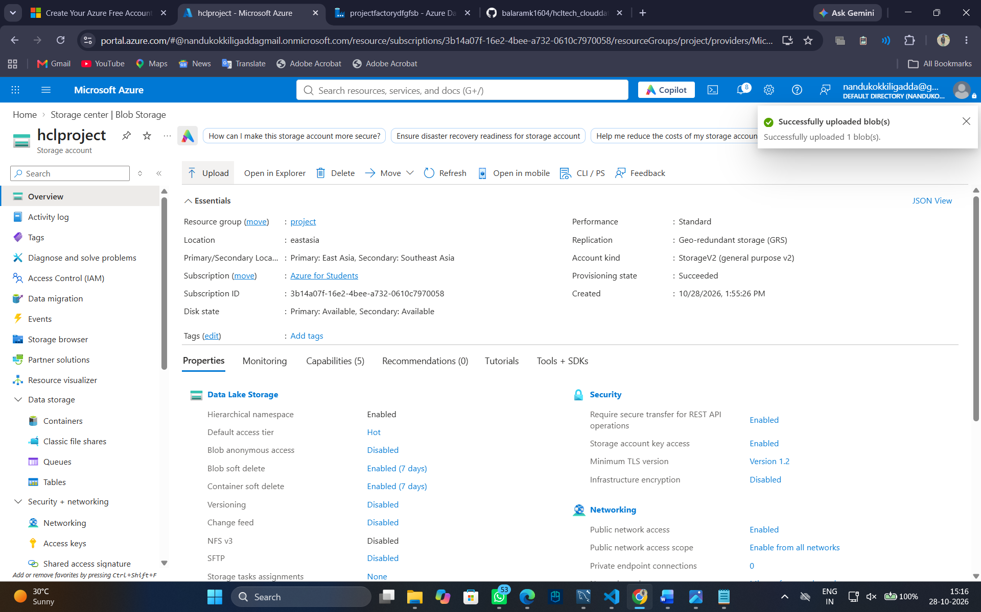
- Create a filesystem or container and upload a sample dataset.
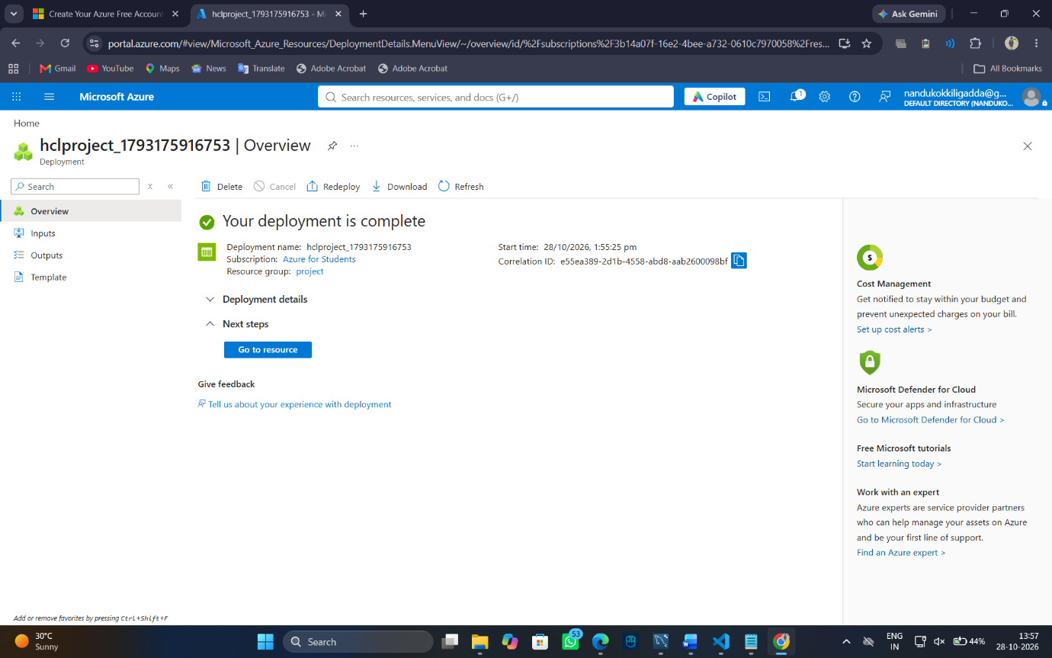
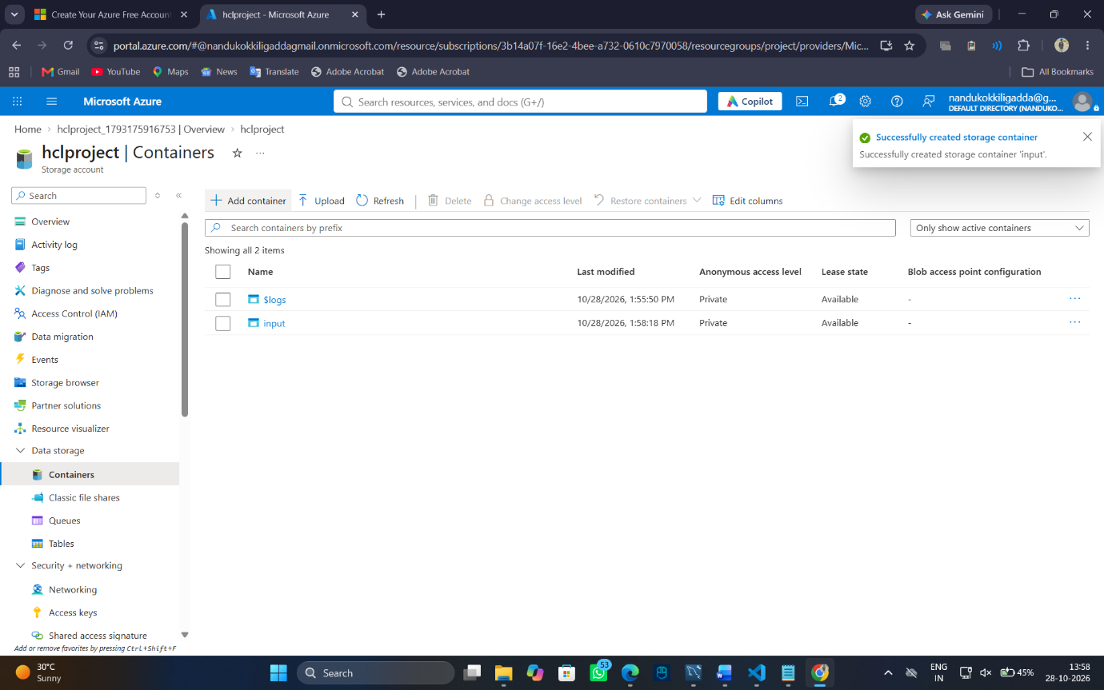
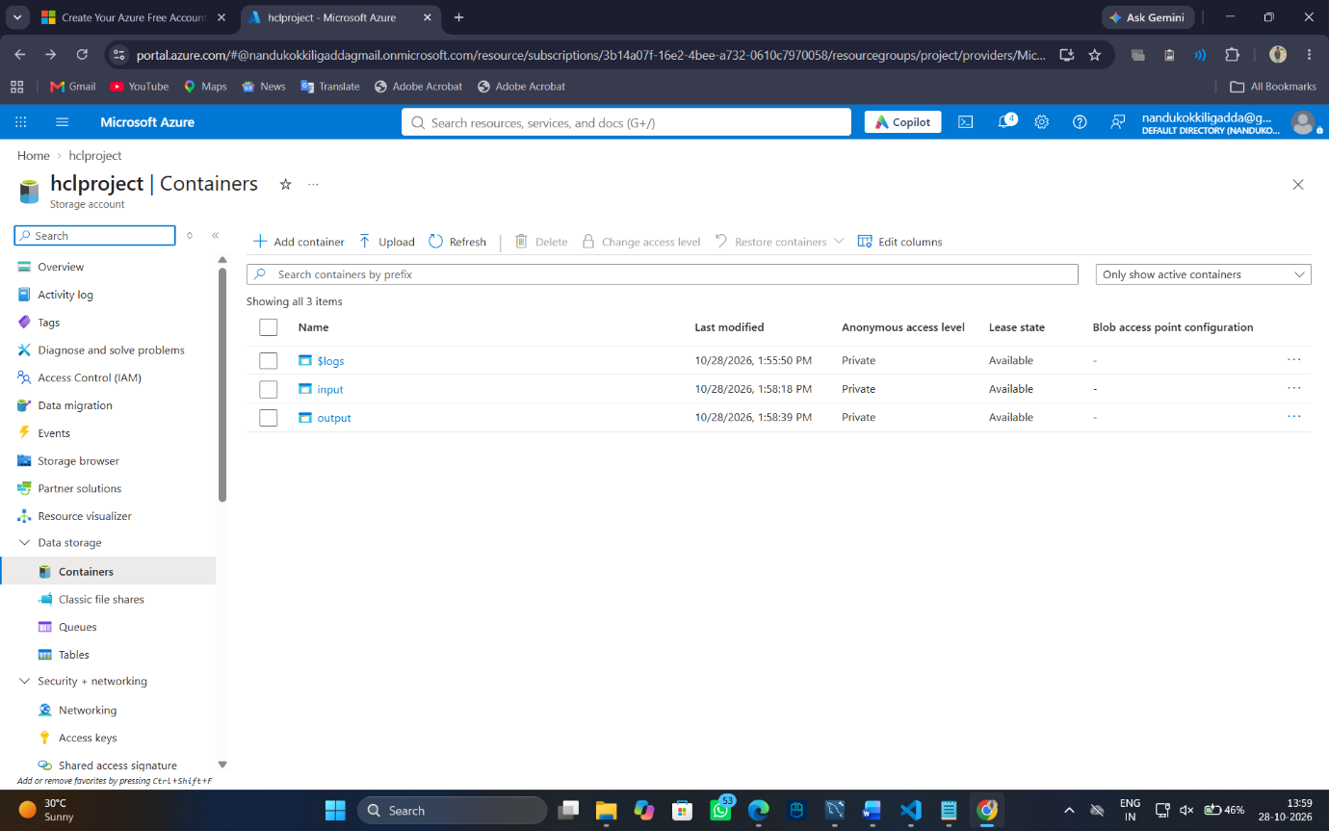
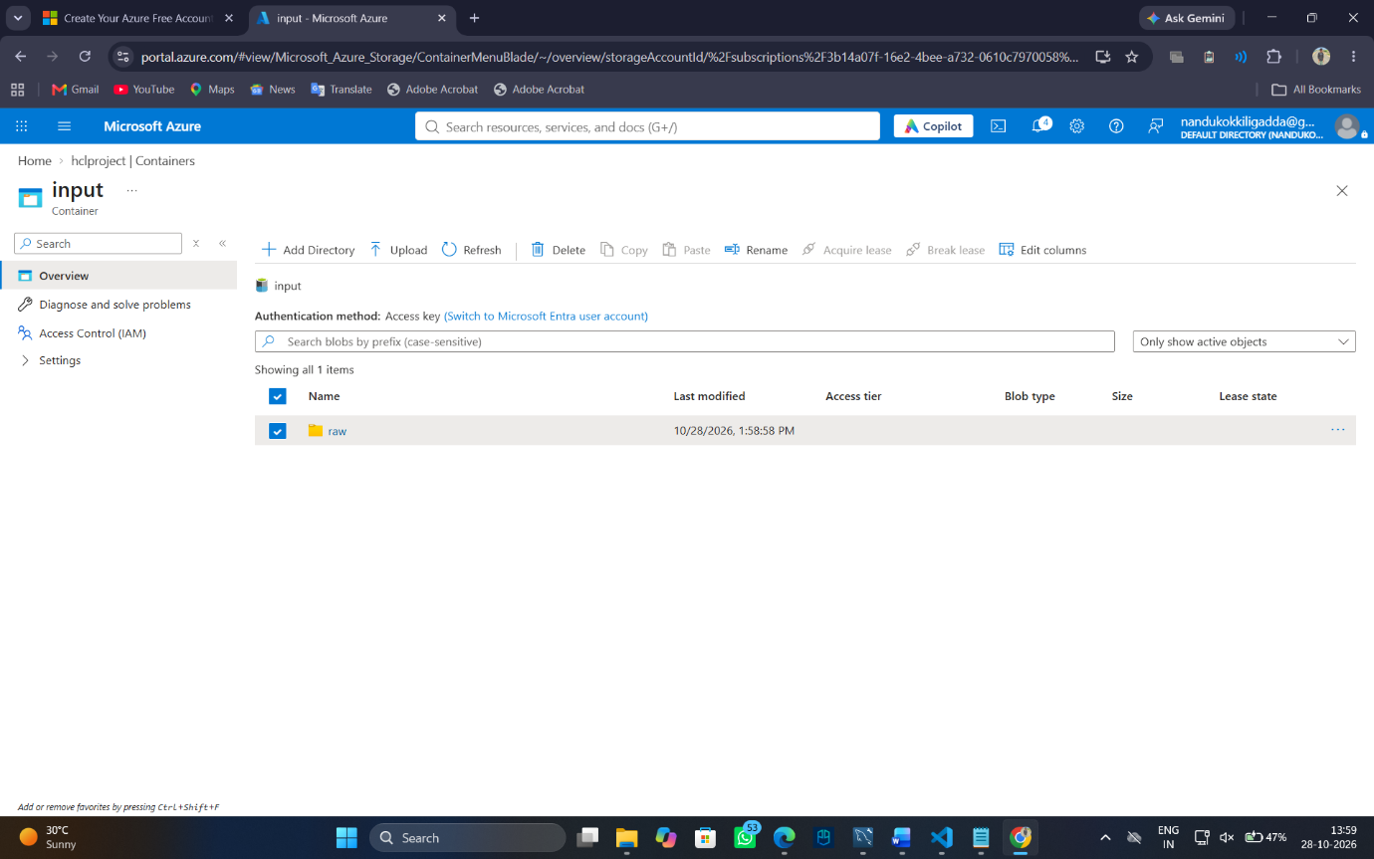
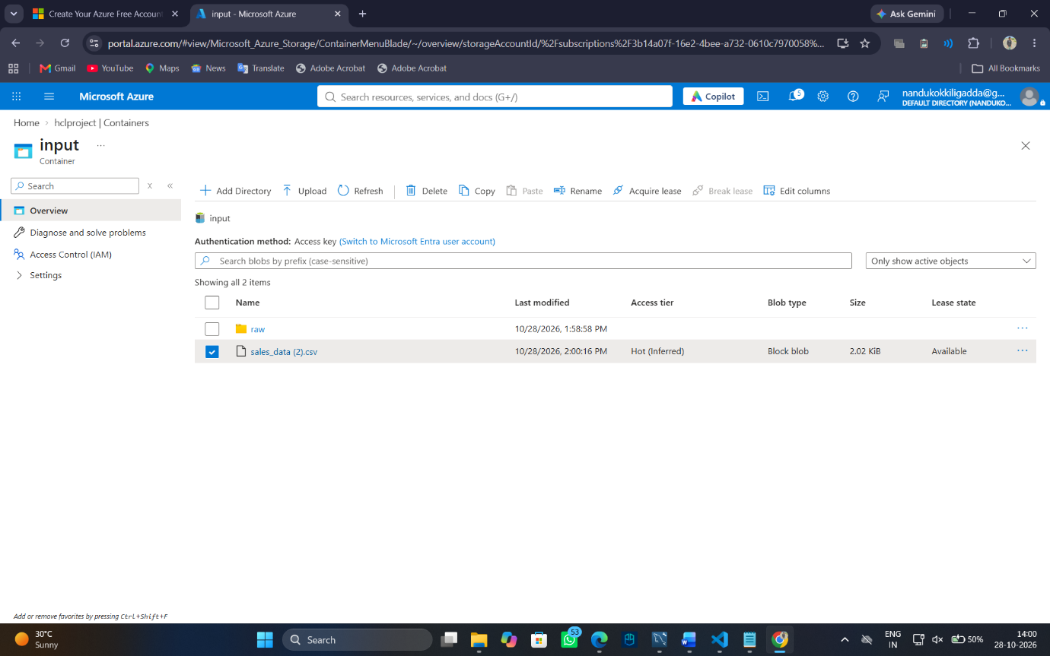
- Explain how Microsoft Entra ID and Azure role-based access control can manage access to the data.
Microsoft Entra ID provides identity and authentication. Azure role-based access control (RBAC) assigns permissions to users, groups and service principals.
Suitable roles include:
Storage Blob Data Reader: Read data without modifying it.
Storage Blob Data Contributor: Read, write and delete data within the assigned scope.

- Explain how you would verify that unauthorized users cannot access the dataset.
Assign the least-privilege role at the appropriate storage account, container or supported directory scope. Azure Data Lake Storage Gen2 also supports POSIX-style access control lists (ACLs) for directory and file permissions.

Question 16: Azure VM Troubleshooting
- Verify the VM's provisioning and power states.
In the Azure Portal, navigate to Virtual Machines and select the VM. Check:
Provisioning state: Succeeded, Failed or another reported state.
Power state: Running, Stopped, Deallocated or another reported state.
- Explain how Network Security Group rules can prevent connectivity.
NSGs contain inbound and outbound rules that permit or deny network traffic. A missing SSH rule for TCP port 22 or RDP rule for TCP port 3389 can prevent connections. Rules are evaluated according to priority.
- Explain how subnet and routing configuration affect connectivity.
An incorrect subnet configuration, user-defined route, route table or next-hop setting can prevent traffic from reaching the VM. Verify the effective routes, subnet association, network interface configuration and any required gateway or peering connections.

- Recommend a secure troubleshooting method that avoids unnecessarily exposing the VM to the public internet.
Use Azure Bastion to connect to the VM over SSH or RDP through the Azure Portal without assigning the VM a public IP address.
Additional checks:
Use Network Watcher connection troubleshooting.
Review NSG effective security rules and effective routes.
Check VM boot diagnostics and serial console where supported.
Avoid opening SSH or RDP to the entire internet.

Question 17: Azure Data Integration

- Select an appropriate service to orchestrate data movement.
Use Azure Data Factory (ADF) to orchestrate and automate the data pipeline.

- Explain how to copy the CSV file into Azure Data Lake Storage Gen2.
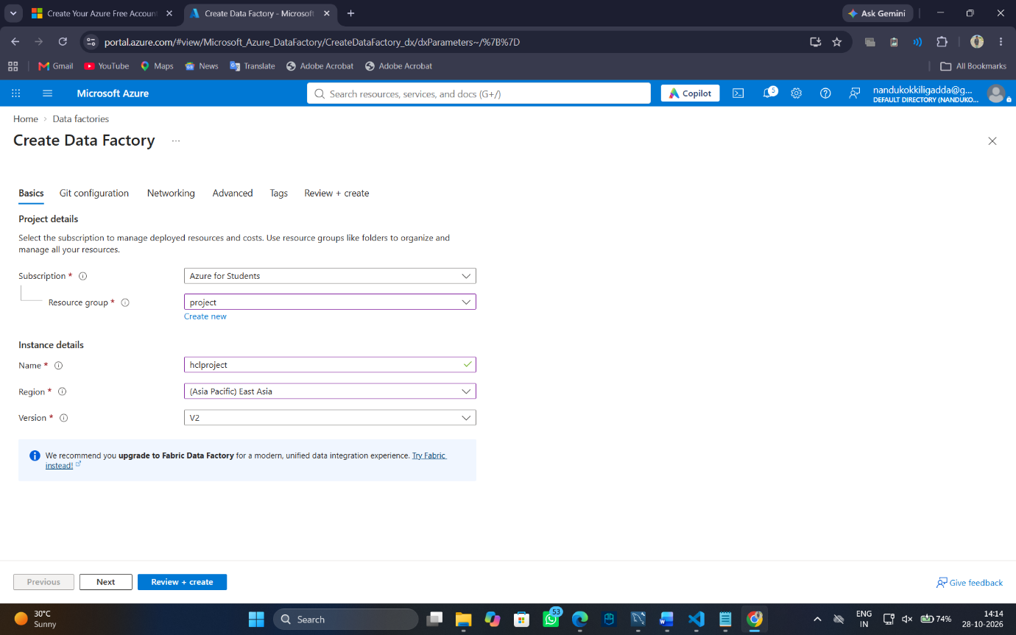
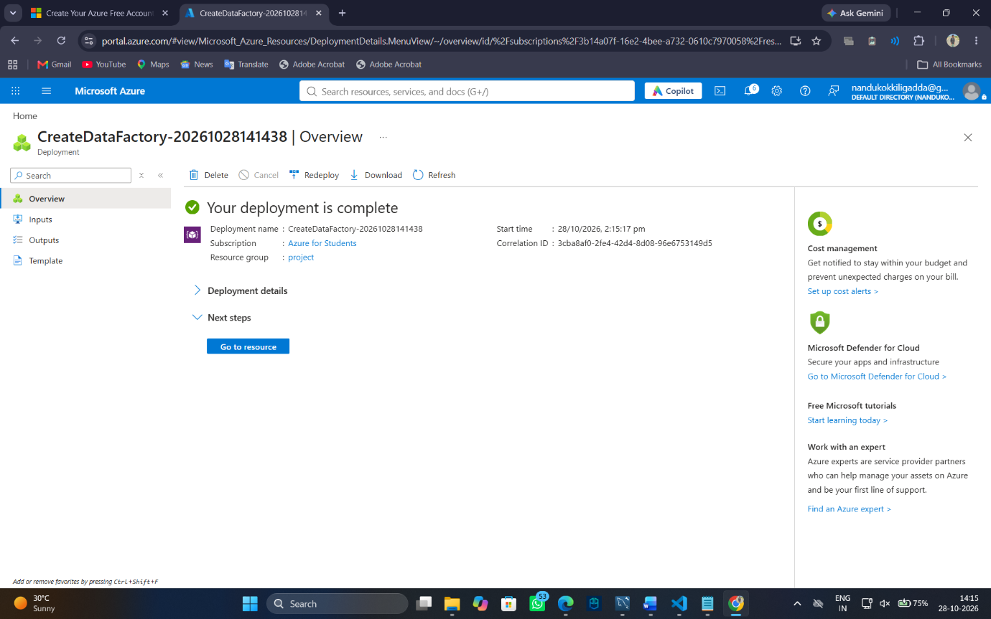
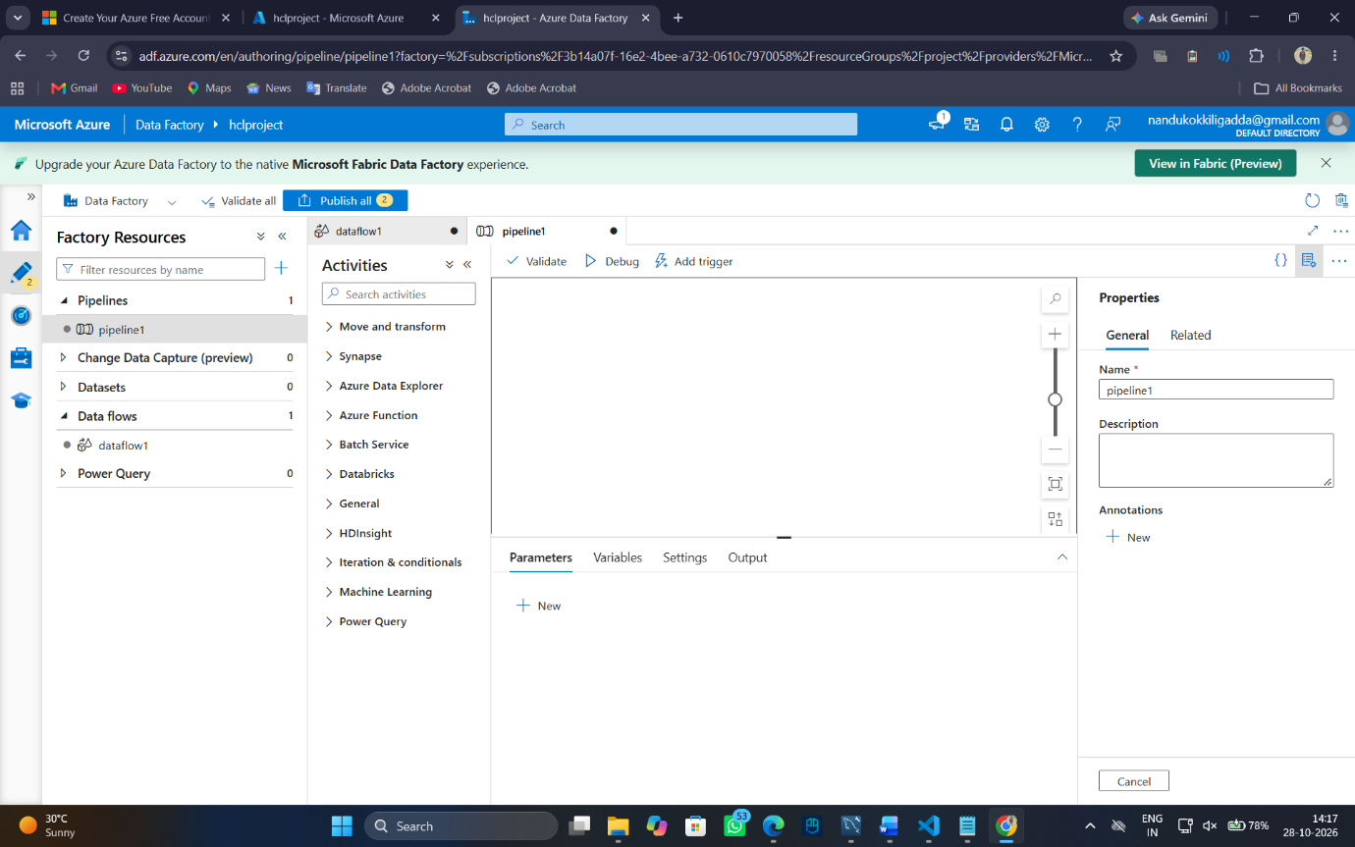
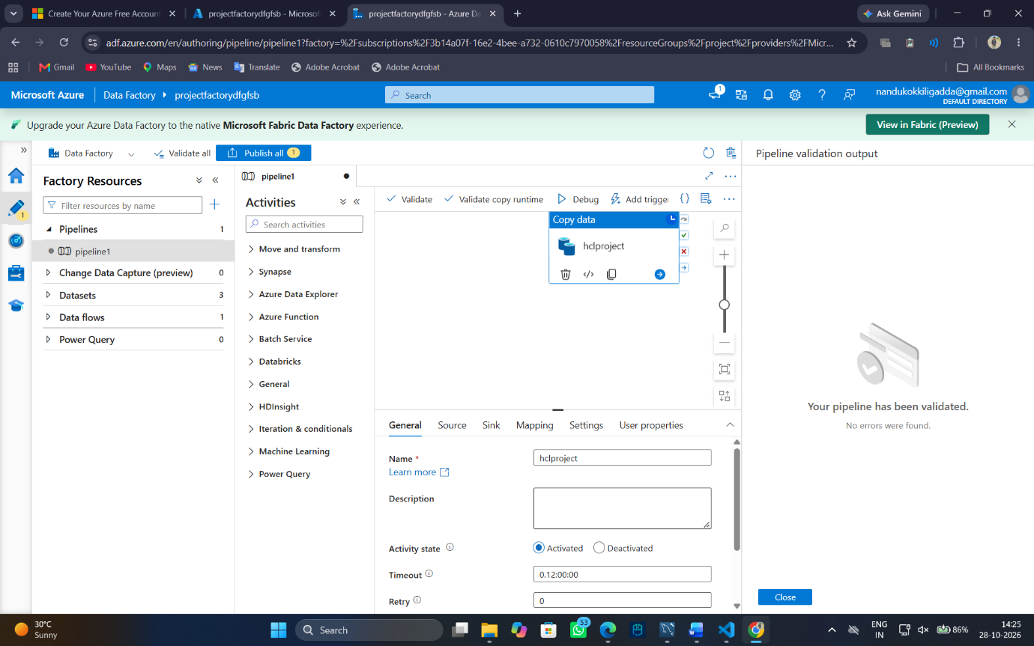
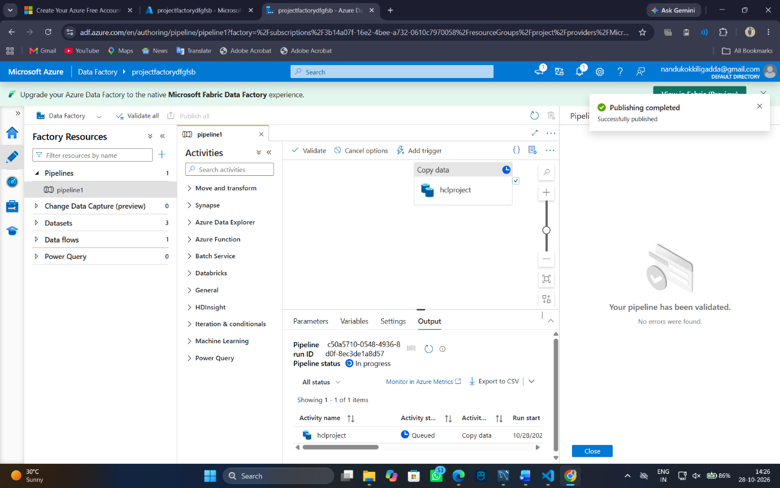
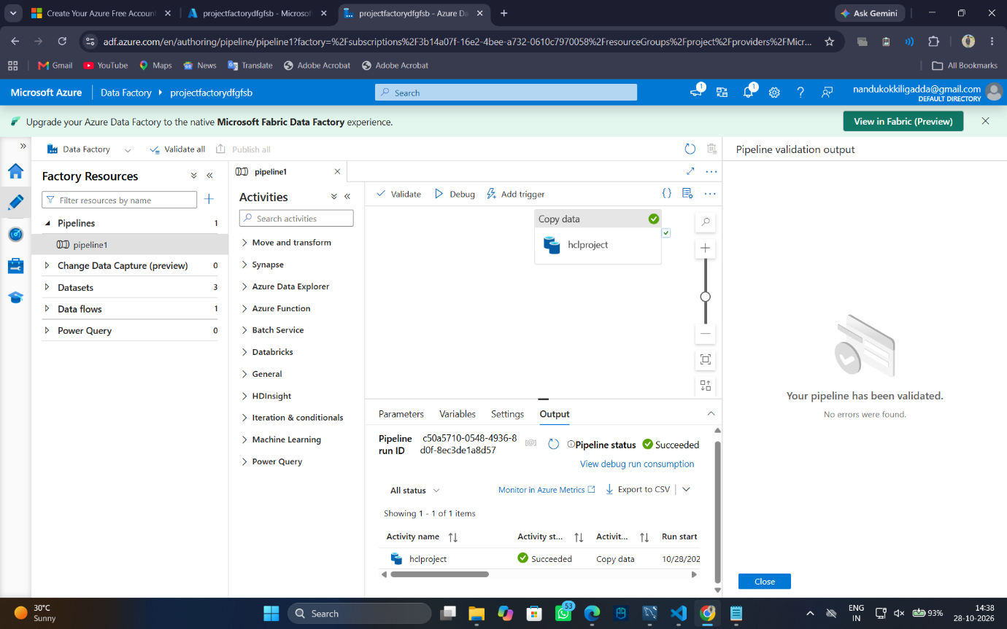
c. Describe how to organize files by ingestion date.
Use date-based directory partitioning,
for example:
/business-data/
year=2026/
month=10/
day=28/
.csv file

d.Explain how to handle malformed records and missing values.
Reject or redirect malformed records to a separate error folder.
Apply appropriate missing-value rules, such as rejecting records with missing required IDs or retaining optional fields as null.
Record error details for auditing and reprocessing.

e. Explain how to monitor pipeline execution and validate data completeness.
Use the ADF Monitor tab to inspect pipeline and activity status, duration, failures and error messages. Configure alerts for failures. Validate completeness by comparing source and destination record counts, checking required fields, and reconciling totals or checksums where appropriate.

